Biennial Report
2016-2018

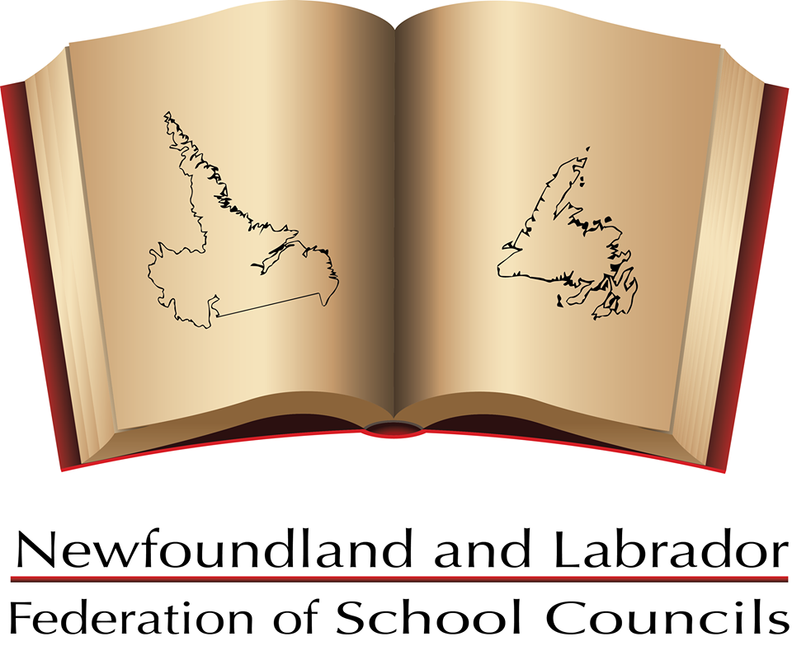

Table of Contents

Introduction

Mission Statement

Executive Report

Membership

Communication

Representation

Partnerships

Teacher/Staff Appreciation Week

Report on the 36th General Meeting

2016 – 2018 BOARD OF DIRECTORS
______________________________________________________________

- Paulette Fifield, President (2016 – March 2018) | Grand Falls - Windsor, NL

- Terry Green, Vice-President (2017 – 2019 - resigned March 2018) | Grand Falls - Windsor, NL
- (Position currently vacant until replacement appointed by executive)

- Craig Tavenor, Vice President, Appointed (March 2018 - Oct. 2018)

- Lori Barry, Secretary, (2017 - 2019) Grand Falls - Windsor, NL

- Michele Peach, Treasurer | Mount Pearl, NL (Appointed)

- Ruby Hoskins, Past President | Marystown, NL

On October 24, 2018, NLFSC held its first electronic election.

- Donald Coombs of Carbonear was acclaimed as President

- David Hillier of Grand Falls Windsor was elected as Vice-President

On behalf of the NLFSC members, thank you Don and Dave for offering yourself for these positions. Both positions were effective immediately.

INTRODUCTION
___________________________________________________________________________________

The Newfoundland and Labrador Federation of School Councils (NLFSC) is the provincial umbrella group for parents, teachers, high school students (where applicable), and community supporters who are committed to enhancing the quality of school programs and improving the levels of student achievement in our schools. The Federation provides School Councils and parent groups with a voice on educational issues and encourages parental involvement at all levels of education.

NLFSC is a non-profit organization governed by a volunteer Board of Directors. Membership consists of School Councils, school-based parent groups, Home and School Associations, Parent-Teacher Associations, and Parent Advisory Committees. Membership is optional and renewed annually.

As a major stakeholder in education, the NLFSC continues to work on issues affecting its membership and often seeks to provide input into policy and programs that have an impact on school communities. NLFSC is working to strengthen communication between the Department of Education, School Districts, the Federation, and School Councils. NLFSC works with these educational partners to bring areas of concern to the attention of many organizations, most frequently Departments of the Government of Newfoundland and Labrador.

The founding meeting of the Newfoundland and Labrador Federation of Home & School and Parent-Teacher Associations was held in Gander on Saturday, October 20, 1979. The Newfoundland and Labrador Home and School Federation was incorporated on July 5, 1994, under the Corporations Act, Revised Statutes of Newfoundland, 1990, Chapter C-36, Section 420. On August 30, 1999, the Articles of Incorporation were amended and the name was changed to “The Newfoundland and Labrador Federation of School Councils, Inc.”

MISSION STATEMENT
___________________________________________________________________________________

The Newfoundland and Labrador Federation of School Councils strives for excellence in education for all children in Newfoundland and Labrador and acts as a collective voice for School Councils and for all parents/guardians. The Federation provides leadership, representation, and services to all volunteers involved with School Councils and parent organizations. The Federation provides parents/guardians with a voice on educational issues and encourages parental/guardian involvement at all levels of education.

NLFSC EXECUTIVE REPORT
___________________________________________________________________________________

The Executive members are pleased to provide our members with the 2016-18 Biennial Report of the NLFSC. This report outlines the activities over the past two years of our operation and will enable members to review the activities, which the Federation has undertaken on behalf of school councils during this time.

NLFSC supports networking among councils. This includes maintaining the connection between the Federation and each individual council, as well as the connection all councils have with each other for information sharing, decision-making, and support.

We truly value the partnership and working relationship between NLFSC and other education stakeholders. By working with professionals who are leaders in their field and by building partnerships with some of the best and more revered organizations in the province, we will be able to further enrich the whole child, entire schools, and communities across the province.

The executive has been very active as we continue with the NLFSC objective to provide a forum for school-based groups to communicate with each other.
Our membership is truly committed to enhancing the quality of education for their children. This is very evident in our daily operations, which include telephone calls, letters and e-mails from school council members, parents and educators on issues such as class size, school closures, school maintenance, teacher and guidance allocations, school council role and functions, and the need for more resources for schools and students. A powerful, united, energetic federation can be an influential voice for education and a catalyst for uniting the support and power of the province on behalf of our students and schools.

The mental health of our school-aged children continues to emerge as a significant public issue. For years, the NLFSC has advocated to government that we are falling short in providing adequate mental health resources for our youth.

We have advocated for an increase in guidance councillors, mental health specialists, addictions specialists, reading and math supports, reduction in class size, increase in time for administrative allocation, Curriculum Support and Instructional Resource Teachers and for changes to legislation to ensure students receive the mental and emotional help they need. We are not always successful in our efforts, but we have ensured the issue is at the forefront of public consciousness.

As NLFSC continues to work on behalf of our students and the schools, the next few years will also prove to be interesting and challenging. There is still much work to be done and the voice of parents and the positive role of School Councils in education is of utmost importance. A strong education system is essential to creating and sustaining the social and economic environment that parents want and seek for their children and this province.

Over the past year, engaging our membership through The Cuffer, e-mail, NLFSC listserv, face-to-face exchanges and by phone has been very satisfying and rewarding. Providing our membership with information and assistance in understanding the challenges and opportunities in education is a fulfilling part of our role.
Regular communications with other key education stakeholders including officials from the Department of Education, NLTA, English School District and other agencies such as the Department of Health and Community Services, Department of Justice, and Memorial University is important and necessary to further the cause of our advocacy work and mandate.

It has been a real team effort and a pleasure to work, on your behalf, with dedicated parents, educators, children, school volunteers, health care professionals, civil servants, and politicians who value what we do.

We feel confident we have effectively articulated our concerns with passion and integrity, raising the prominence of the NLFSC as a vital component of the Province’s education system.

School councils have an important role to play in promoting positive parental engagement in education. Most children have two main educators in their lives – their parents and their teachers. Parents are the prime educators until the child attends an early years setting or starts school and they remain a major influence on their children’s learning throughout school and beyond.

The majority of education research says when schools, families, and community groups work together to support learning, children tend to do better in school, stay in school longer, and like school more. When parents are engaged in education – everyone benefits!

We extend our deepest appreciation to School Councils across this province for your leadership, advice and support. You have provided us with valuable feedback on various issues facing school councils. The dedication and professionalism with which you continue to serve your communities is admirable. Thank you for your shared commitment to our children's education.

Submitted by the Executive of the Newfoundland and Labrador Federation of School Councils

MEMBERSHIP
___________________________________________________________________________________

Membership provides the opportunity for individual School Councils to raise their voices with others throughout the province on issues and concerns with our public education system. It is important to recognize that the success of all efforts in our organization must rely on the value the NLFSC can bring to members, whether the school community is an active participant in programming or not.

In order for NLFSC to continue to be an effective voice, it must maintain a high level of member participation and awareness. Membership ensures that your Council’s voice is heard on issues that affect our students. It also provides an opportunity to promote the importance of parent education, communication, and leadership development. Getting involved with School Councils and the Federation builds skills in leadership, communication, and advocacy.

Membership stability and growth is extremely important to the continued success of NLFSC and we are pleased to report that our membership has increased over the past year. To ensure our success, please keep your membership up to date.

COMMUNICATION
___________________________________________________________________________________

The NLFSC Executive Director and Executive engage in daily communications and interactions with its member councils providing information and guidance on matters pertaining to membership, local school issues, and various other education topics.

The Executive communicated daily through e-mail and held 2 face-to-face meetings as well as 4 teleconferences during the past year. Some of the topics discussed include: Mental Health and Addiction Supports, Bullying, Teacher, Administrative and Guidance Allocations, General Meeting Planning, Media Interviews, Student Mental Health and Addictions, Provincial Election/Education Priorities, CRT and IRT resources, NFLSC Funding, School Council Training and Funding, Changes in the Curriculum, Violence in school, Literacy, Full Day Kindergarten - and numerous other concerns from individual School Councils.

Some of the topics NLFSC championed include:

Negative Impact of cuts to Teachers and Guidance Allocations
Regulations on electronic cigarettes and nicotine refills
Importance of School Council Empowerment
Inclusive Education
Bullying & Violence Prevention
Mental Health and Addictions Supports
Increase to Administrative Allocation
School Transportation
Special Services Teacher Allocation
Student Assessment and Evaluation
Cuts to Specialist Teacher Allocation
Legislative Changes for Secured Treatment
Literacy
Provincial Prescription Monitoring Program
Curriculum and Instructional Resource Allocations
Increase to the Educational Psychologist Allocation
Increase in Operational Grant for School Councils and NLFS
Math and Numeracy Challenges
Student Conduct and Social Media Policies
School Construction and Renovations
Healthy Eating/Living
Importance of Parental Involvement in Education
Bus Safety

PRESS RELEASES
___________________________________________________________________________________

Throughout the past two years NLFSC issued a number of Press Releases regarding:

Back to School

Education Week

The Prime Minister’s Award for Teaching Excellence

Provincial Budget

Volunteer Week

Meeting with Education Minister

Pink Shirt Day

Assessment, Evaluation and Reporting Policy

Call for Government to Invest in Education

Fire at Bay d'Espoir Academy

Teacher Staff Appreciation Week

Now is the Time: NLFSC encourages School Councils to speak up for Education

Cuts to Student Assistant Time

Violence Increasing in Schools

End of School Year

Election Results: New NLFSC President and Vice-President

Various school issues that arose in the media

Executive members gave media interviews (CBC Radio and TV, NTV, VOCM talk shows and and several newspapers) on educational issues affecting our schools, students, and School Councils.
Over the past two years, NLFSC has promoted the mandate and goals of NLFSC in the media. We were a voice for parents and School Councils on numerous education issues and concerns.

During Teacher/Staff Appreciation Week February, 2017 and 2018, the NL Federation of School Councils and Honourable Dale Kirby, Minister of Education, issued a joint press release thanking our Teachers and School Staff for the care and guidance they give our children.
REPRESENTATION
___________________________________________________________________________________

On a provincial level, NLFSC representatives attended meetings, participated in discussions, and made recommendations on programs and policy. Some of the meetings we initiated or were invited to attend include:
- The Premier’s Task Force on Improving Educational Outcomes
- Community Sector Council
- NL School Food Environment Assessment
- Launch of the Immigration Action Plan.
- Director of the Recreation and Sport Division
- Linda Carter, Director of the Healthy Living Division within government
- Gary Rabbior, President Canadian Foundation for Economic Education (CFEE)
- Christine Green, Provincial Coordinator for the Talk with Your Kids About Money Program
- Stakeholder Forum on the Legalization of Cannabis
- Mental Health and Addictions Action Plan
- Release of the Premier’s Task Force Report on Educational Outcomes
- Capacity Building Workshop and Working Session on Individualized Funding by the Coalition for Community Living
- VOCM Round Table Discussion on Money Matters/ Financial Education
- Teacher Induction Ceremony
- Provincial Planning Forum on Food Security
- Premier's Round Table on Immigration
- NLTA
- Alliance for the Control of Tobacco (ACT)
- English School District
- School Food Environment Focus Group
- Association for Community Living Fundraiser
- Community Sector Lunch on Volunteerism
- Kids Eat Smart Healthy Roots
- Invitation to attend the New Brunswick Home and School Meeting
- Invitation to attend the Nova Scotia Home and School Meeting
- Launch of the Premier's Task Force Action Plan
- School Food Guideline Assessment Advisory Committee
The NLFSC’s newsletter, The Cuffer, which is usually sent out five times per year, is a benefit of membership in the Federation.

NLFSC has a toll-free telephone line for the convenience of members: 1-877-739-4830.

One of the key instruments of communication for the Federation is the membership listserv, which facilitates a quick information exchange. When councils register as members of the Federation, they have the option of including their e-mail addresses for the listserv. The listserv is used on a regular basis to inform our membership of any changes relative to NLFSC or our schools. It is also a great medium to gather immediate feedback on issues of concern.

The NLFSC sets its agenda and initiates responses to media on the information sent through the listserv. The names of schools and School Councils members, who respond via the listserv, are always kept in the strictest of confidence.

To strengthen communication with our membership, NLFSC has a Facebook page and a website: www.schoolcouncilsnl.ca

During the year, NLFSC corresponded via e-mail, telephone, mail, and attended in-person meetings, with the Department of Education, the English as well as other government agencies and organizations on issues relating to education.

MEETINGS
___________________________________________________________________________________

On March 3, 2017, the NLFSC Executive met with Dale Kirby, Education Minister and other representatives of the Department of Education and Early Learning.
The executive also took the opportunity to talk about the NLFSC goals, funding and Pre-budget Submission. The discussion also included a discussion on the NLFSC Resolutions

On March 9, 2018 the NLFSC Executive met with Minister Kirby and other representatives of the Department of Education and Early Learning. Topics discussed include literacy, mental health and addictions, Inclusive Education, Curriculmn Support Teachers, Instructional Resource Teachers and recommendations from the Premier's Task Force.

NLFSC met with NLTA several times during the past year. NLFSC continues
to maintain a strong relationship with the NLTA and share many of the same education concerns and advocacy goals .

Members of the NLFSC also met with representatives of NL English School District through the year

The executive met with members of the Premier's Task Force on January 27, 2017.
Topics included:
Teacher, Administrative and Guidance Allocations, Inclusive Education, Truancy, Mental Health and Addictions, Literacy and Numeracy, School Council and NLFSC Funding, Cuts to Curriculum Support Teachers and Specialist Teachers.
PRE-BUDGET SUBMISSION
___________________________________________________________________________________

NLFSC submitted a pre-budget report, in both years, to the Department of Finance for consideration. Some of the recommendations put forth by NLFSC include:

- Develop a plan to increase the number of IRTs, CST’s, SAs, and counsellors in schools. The allocation formula for students with challenging needs should be truly ‘needs based assessment’ and generous in application.

- Revisit the extent and extreme issues on inclusion – consider the creation of an alternative path for some children. In such cases initiate training and assess support in preparation for a return to school. Create training and support programs for parents of LD and ASD children, and others as needed.

- Provide special supports to enable students with special needs and mental health issues to access the same opportunities as their peers.

- Give serious consideration to the inclusion of Social Workers and Occupational Therapists as professional employees within the schools in the near future.

- Reinstate the Administrative allocation to the level it was in 2012.

- Increase the current Educational Psychologists allocation to 1:100

- Increase the current Guidance Counsellor allocation to allow 1 per 333 students from Kindergarten to Level III.

- Create a new allocation for Youth Mental Health and Addiction Counsellors, at a ratio of 1:500 students.

- Create a specific allocation for Curriculum Support Teachers

- Reduce Class size
Kindergarten – 18 students
Grades 1-3 – 20 students
Grades 4-6 – 23 students
Grades 7-12 – 25 students)

- Additional teaching units to address needs identified and associated with the implementation of the inclusive model of education that arise during the school year.

- Increase the teacher allocation for English Second Language to provide 0.50 teacher unit for every 15 ESL students.

- The Department of Education and Early Childhood Development develop and implement a comprehensive approach to early identification and intervention on literacy by:
a) building on the work that has already been done in Working Together for Student Achievement
b) allowing schools to continue to implement programs that demonstrate research evidenced effectiveness such as Levelled Literacy Intervention, Reading Recovery and Barton Reading.
- The Department of Education and Early Childhood Development adopt a proven, research- based early assessment tool to be administered at the start of Grade 1 to identify students who require additional support in learning to read.
- The Department of Education and Early Childhood Development provide a separate teaching allocation to be dedicated as school-based reading specialists who will work directly with students:
a) who are reading below grade level in Grades 1 and 2 as determined by early reading assessments;
b) who continue to read below grade level in Grades 3 – 6 as determined by school assessments.
- The Department of Education and Early Childhood Development allocate five permanent program specialists with expertise in reading instruction to provide leadership and curriculum support to the school-based reading specialists.
a) The program specialists should be deployed as follows: one in each of Labrador, Western and Central regions and two in Eastern region.
b) A protocol to ensure that the roles and responsibilities for K–6 reading program specialists are sustained over time should be developed.
- The Department of Education and Early Childhood Development explore options with Memorial University’s Faculty of Education or another Canadian university for a graduate level specialization program to prepare reading specialists.
- The Department of Education and Early Childhood Development develop and implement a reading intervention program for Grade 7 – 12 students who experience reading difficulties.
- The Department of Education and Early Childhood Development review and revise how it calculates and reports graduation and pass rates so that these statistics more accurately reflect student achievement.

- The Department of Education and Early Childhood Development review and revise the language arts curriculum to ensure that it sets clear expectations to inform teaching and learning and contains reading materials that are responsive and meaningful to students.
- The Department of Education and Early Childhood Development increase the capacity of school libraries and teacher-librarians to support the curriculum by ensuring provision of sufficient library resources and personnel.

PROVINCIAL BUDGET
___________________________________________________________________________________

Each year, the President is invited (by the Premier’s Office) to a Provincial Budget Lock-Down at the Department of Education for a briefing on the fiscal impact to education. The President is also invited to the House of Assembly for reading of Provincial Budget.

PARTNERSHIPS
___________________________________________________________________________________

NLFSC has a long-time partnership with other provincial agencies connected to education including: Alliance for the Control of Tobacco NL (ACT), Kids Eat Smart Foundation NL and The School Milk Foundation, School Administrator Council, and English and French School Districts.

As well, we partner with various government Departments, Memorial University, and numerous Community Agencies. NLFSC often supports the above mentioned by including information regarding various programs, new initiatives, and changes to policies through articles in The Cuffer and by e-mail to our members via the listserv.

TEACHER/STAFF APPRECIATION WEEK
___________________________________________________________________________________

Every year NLFSC recognizes educators and school staff for educating and nurturing our students during Teacher/Staff Appreciation Week.

School Councils and Home and School Associations across Canada celebrated National Teacher/Staff Appreciation Week in the month of February in both years. During those weeks hundreds of teachers and other school staff members such as secretaries, teacher assistants, nurses, bus drivers, and custodians (across the province) were recognized for their contribution to the education system.

The popularity and celebration of Teacher/Staff Appreciation Week is growing each year. The Federation encourages parents and the wider community to thank teachers and school staff for educating and caring for our students and provides our membership with a list of ideas to incorporate into the celebration.

REPORT ON THE 2016 Biennial Business Meeting (official minutes in registration kit)
________________________________________________________________________________

The Newfoundland and Labrador Federation of School Councils Biennial Meeting took place at the Gander Hotel on Saturday November 26, 2016.

The Chair for the Business Meeting was President Paulette Fifield, while Executive Director Denise Pike served as the Parliamentarian.

There were 18 voting delegates in attendance, 3 non-voting and 11 proxy’s to establish the
quorum. Business included the presentation of the Annual Report, President’s Report, and a Town Hall discussion on education concerns.

Delegates voted to support a resolution on Healthy Eating for School Sporting Event
canteens. The resolution directs NLFSC to support School Districts in the development and implementation of a Health Eating Policy (similar to the current Nutrition/Healthy Eating and Living Policy) that specifically requires school sporting event canteens to be junk free and/or sell healthy food and beverage choices.

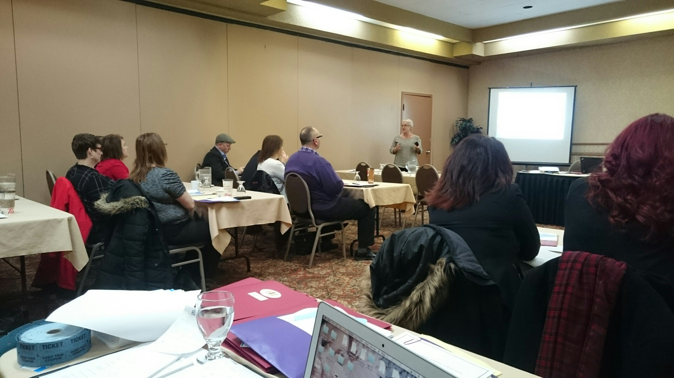

Election of Officers:

Terry Green - NLFSC Vice President for the term of 2016-2018 (elected unopposed)

Lori Barry – NLFSC Secretary for the term of 2016-2018 (elected unopposed)

Speakers

The Hon. Dale Kirby, Minister of Education and Early Childhood Development, brought greetings and participated in the morning sessions.
Other speakers, representing the Department of Education and Early Childhood included:
Bernie Ottenheimer, Director of Student Support Services Division (Topic: LGBTQ Inclusive Practices in K-12 Education) and
Ron Smith, Director of Evaluation and Research Division (Topic: Measuring Performance in Education).

One of the main education concerns identified during the Biennial Meeting was the impact of cuts to the allocations for Curriculum Support Teachers.
Advocating for an increase to this allocation will be one of the future priorities of the Federation.

The theme of the Conference “Parents as Partners in Education” highlighted the need for more positive parental involvement in education and the affect it can have on student
achievement.

The Executive of NLFSC will meet with the Minister of Education and representatives of the English School District to discuss the issues put forth by the NLFSC membership during the Biennial Meeting. An update will be provided to our members.

AWARDS
___________________________________________________________________________________

2016-17 NLFSC School Council Person of the Year Award

The 2016-17 School Council Person of the Year Award was awarded to Jeanine Hancock, St. Joesph's Elementary in Harbour Breton.

The 2017-18 School Council Person of the Year Award was awarded to Jennifer Howse, Smallwood Academy in Gambo.

The nomination form and information that accompanied these 2 nominations are a credit to recipients personally and speaks highly of their commitment to the students in their respective schools.
Sincerest congratulations!

A Note of Thanks
___________________________________________________________________________________

Thank you to the School Councils that were represented at the Biennial Meeting.
We appreciate your effort in finding the resources and time to attend the conference.
NLFSC thanks the Department of Education for providing financial support through our annual operational grant and assisting with the cost of our Biennial Meeting.
NLFSC gratefully appreciates the collaboration and support of the Newfoundland and Labrador Teachers' Association. The NLTA also provided financial support for our Biennial Meeting by covering the cost of nutrition breaks. This contribution is greatly appreciated.

Thank you to Dr. Glyn George, past NLFSC executive member and recipient of the NLFSC Life Membership Award, for his continued support, expertise and advice on the NLFSC constitution and parliamentary operations.

NLFSC also appreciates the support and guidance by members of the NLFSC Nomination Committee
(Jeannie Stapleton, Dr. Glyn George, Siobhan J. Foley-Lambert and Renee Furlong)

