###### 

**The Cuffer**

A newspaper for School Councils in Newfoundland and Labrador

**Nov/Dec 2018**



 **Message from the President**

I am honored to bring greetings to you in my new position as President of the NL Federation of School Councils.  I am prepared to bring my experience and professionalism to this position and I look forward to working with members of the current executive with a vision and plan to ensure the best possible education opportunities are available to all students and school in our province.

School Councils play a significant role in the lives of our youth. Effective School Councils result in progressive school communities, which benefit students by fostering enriched learning environments. I believe each school council in NL can make a difference in the lives of students through education advocacy.

NLFSC will continue to empower school councils by providing them with a voice as we advocate on behalf of students for the necessary resources and supports needed to help them achieve their full potential.

One of the NLFSC’s primary goals is to engage parents as much as possible in their children’s learning. We all know learning begins at home and parents are their child’s first teacher. School councils can play a major role in helping this continue as children progress at every grade level.

Our membership is truly committed to enhancing the quality of education for their children. This is very evident in our daily

operations, which include telephone calls, letters, and e-mails from School Council members, parents, and educators on issues such as bullying, mental health and addictions, school closures, math and literacy, school maintenance, teacher and guidance allocations and the School Council role and function.

We firmly believe that providing quality education and social supports for our young people is the key to continued prosperity for Newfoundland and Labrador. Education is not just about our labour market prospects. Education is about providing opportunities for children to learn, succeed, and obtain the supports they require to live healthy and happy lives. Education is about building an equal playing field for our children regardless of socio-economics, gender, sexual orientation, language, status, or disability.

With a provincial election taking place in 2019 this is a critical time to unite to ensure education is at the top of government’s priority list.

We are encouraged by the recommendations resulting from the report by the Premier's Task Force on Educational Outcomes. We also applaud the action plan which hopes to address some of the concerns in the education system -particularly when it comes to Inclusive Education and Student Mental Health and Wellness. However we cannot become complacent in our advocacy efforts to ensure these promises and changes take place in a timely manner. Now *is* the time to provide our schools and students with the proper resources and supports needed to improve and enhance their educational experience.

Throughout the remainder of the school year NLFSC will continue to raise awareness about the importance of educated Newfoundlanders and Labradorians as a key to sustaining a vibrant, dynamic province in the future.

As we move forward to face the challenges in our education system, we must continue to encourage parents and guardians to become active participants in their child’s education. Education must continue to foster and develop the individuality of students, while still providing guidance and the necessary supports for every child to succeed in life.

It is only through open and honest dialogue on all relevant issues that we can provide the best opportunities for all children in Newfoundland and Labrador. We need to continue to build bridges to develop strong, positive working relationships with our education partners. Although we may disagree occasionally, we must remember that we are all working towards what is best for the students in our system.

For it is through positive partnerships and collaboration that we will achieve our common goals for education and for Newfoundland and Labrador.

I look forward to working with you as we continue to advocate for our students.

Please feel free to contact me at any time with concerns or questions you may have, or contact the NLFSC Office.

Don.Coombs@easternhealth.ca

Don was acclaimed as NLFSC President on Oct. 24th.

He is a member of the St. Francis School, School Council in Harbour Grace and

Carbonear Collegiate, School Council in Carbonear.

Don resides in Harbour Grace and is employed as the Chief Development Officer for the Trinity Conception Placentia Health Foundation.

His volunteer efforts and accomplishments include:

* Mayor of Harbour Grace for 19 years.
* Deputy Mayor for 1 year, councilor for 4 years.
* Chair of the Trinity Conception Jumpstart Foundation Chapter
* President of CBN Minor Soccer Association
* Founding Chair of the CBN Indoor Soccer Association
* Recipient of NL Soccer Association Volunteer of the Year and Queens Jubilee Medal
* Honorary Life Member of the Harbour Grace Volunteer Fire Brigade

Don has also served on numerous local and provincial committees. He believes in and stands for fairness, open dialogue and obtaining results in a positive professional manner.





**Congratulations are also extended to David Hillier who was elected as NLFSC**

**Vice-President on Oct. 24th.**

Dave is a member of Sprucewood Academy School Council in Grand Falls-Windsor.

As father of a school aged child (Mya) Dave has a personal stake in the NL school system. His desire to ensure his daughter has the best education possible fuels a passion for promoting, enhancing and ensuring that the education system in NL meets the needs of every child.

Dave strongly believes in empower our children and giving them a voice in their education and the things that will affect them the most. He also believes that accountability and a strong working relationship amongst all stakeholders in education is what will drive our education system forward in a positive direction.

Dave is currently serving his third term on the school council at Sprucewood Academy serving as secretary for the past year.

Dave is currently an Employment Officer with the College of the North Atlantic. He serves on

the NAPE Legislation Committee and is also a member of the executive of NAPE Local 3102.

Vice-President Hillier has 15 years of experience working in the public service. His

previous employment includes Policy & Research Analyst with the Newfoundland and Labrador Board of Commissioners of Public Utilities (PUB), and the Student Aid Division and Income Support Division of the Department of Advanced Education, Skills and Labour.

Dave is happiest when reading Harry Potter with his daughter Mya, or playing and losing to her in all kinds of board games

The other NLFSC executive members are: Lori Barry (secretary), Grand Falls-Windsor and

Ruby Hoskins (past president), Marystown.





**School Councils**

School councils can have a positive impact on the learning success of children in schools across this province.

School Councils are the legislated platform for parent engagement in K-12 public education and a fundamental vehicle for communication. The school council’s role is to be the link between the school administration and the parents in the school community.

We receive many phone calls requesting a copy of the School Council Handbook. Unfortunately the government stopped printing them a number of years ago; however a copy of the School Council Handbook (Building Learning Communities: A Handbook for School Councils 2nd Edition), can be downloaded at

[www.ed.gov.nl.ca/edu/publications/k12/Handbook2ndedition.pdf](http://www.ed.gov.nl.ca/edu/publications/k12/Handbook2ndedition.pdf)

This document is an invaluable resource in

assisting school council members to understand their roles and responsibilities.

If you have questions or concerns, please contact the NLFSC office at (709) 764-8993 or by e-mailing us @ nlfsci@gmail.com

**Membership Renewal**

**It’s that time of year again….time to renew your annual membership in NLFSC.**

**Why should your school be a part of NLFSC?**

**Our commitment to education is the driving force behind everything we do.**

Your continued membership will help support our mission to advocate for excellence in

education for all students in Newfoundland and Labrador.

Your membership allows NLFSC to continue to represent the concerns of School Councils.

The NL Federation of School Councils is the provincial umbrella group for School Councils, provides school councils and parent groups with a voice on education issues, and encourages

positive parental involvement at all levels of

education.

The Newfoundland and Labrador Federation of School Councils also offers information, support, and guidance to parents and school councils to help them better understand the policies and procedures of their local schools, school districts, and the Department of Education.

There are many changes and challenges taking place in the school system and NLFSC is busy advocating on your behalf.

If you have not renewed your membership and would like an renewal form, please email us at [nlfsci@gmail.com](mailto:nlfsci@gmail.com)



**Media Interviews and Representation**

Over the past few months the NLFSC Executive has sent out several Press Releases and responded to the media requests for information and comment.

Some of the issues include:

* Violence and behavioral issues in school
* Cuts to teachers, school budgets and Student Assistant time
* The need to implement recommendations, in the report “Now is the Time” by the Premier's Task Force, in a timely manner.
* Encouraging parents/public to speak up for education and contact their MHA's about the importance of predictable, sustained and long term funding for education.
* Additional supports needed for Inclusive Education
* Empowering and engaging School Councils
* 2018 Biennial Meeting
* The Auditor Generals Report on spending activities and polices by the English School District
* Student transportation and safety to and from sports events



**Teacher Induction Ceremony**

The NLTA’s Fall Ceremony of Induction into the Teaching Profession was held on October 3, 2018

The event recognizes the completion of professional studies by students, in the faculty of Education, at Memorial University.

NLFSC congratulates these students on their many years of hard work and study and wish them much success as they begin the journey towards their professional life.



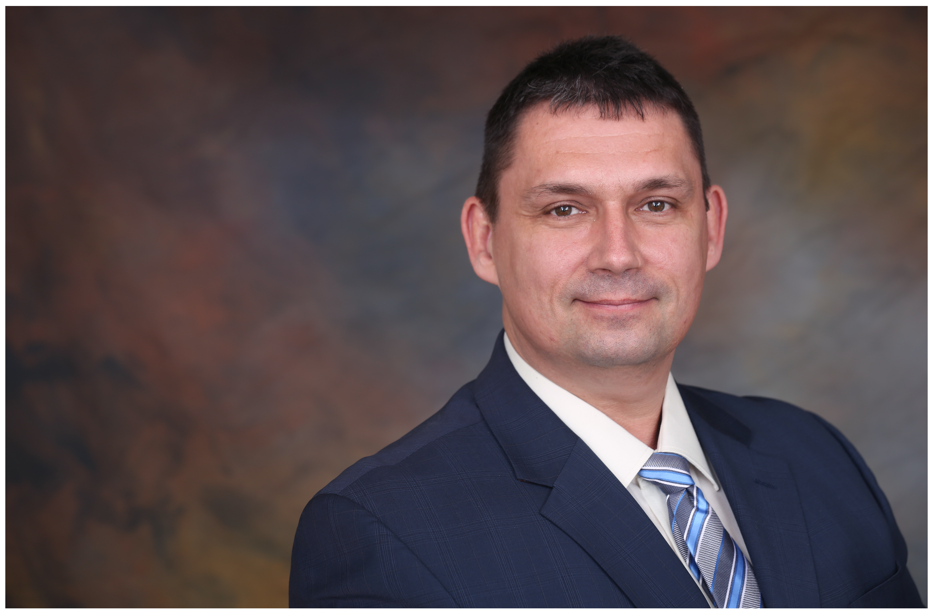

**NLTA President Dean Ingram**

Congratulations to Dean Ingram on being recently acclaimed to a second term as President of the Newfoundland and Labrador Teacher's Association.

This reinstatement speaks to the confidence that teachers all over the province have in his leadership and representation.

The NLTA plays a vital role in the health and well-being of our schools, the teachers who work in them and the children they serve.

NLFSC applauds Mr. Ingram’s visionary leadership and his commitment to improving the public education system in Newfoundland and Labrador.

NLFSC is proud to have such a strong partnership with the NLTA. We have often

been strong allies in promoting children’s educational issues. We share common purposes and common direction that serve parents, teachers and the entire education system. A positive relationship between the NLFSC and the NLTA will assist in the moving the province towards an education system that our students deserve.

Members of the NLFSC executive look forward to continuing to work with Mr. Ingram on shared education concerns.

**Our Principals and the Administrative Allocation**

Principals are among the hardest working, yet quite often the least recognized, individuals in education. Principals set the academic tone for

their schools. It is their vision, leadership and dedication that often motivates staff, students

and the entire school community to pull together to address academic concerns and celebrate success.

The reduction in the allocation for School Administrator time in previous provincial budgets, and the ever-growing workload placed upon them has resulted in less time for School Administrators to carry out their duties and responsibilities.

Cuts to administrative time in schools are having a direct and detrimental impact on our students and schools.

Many of the School Councils we speak with say “Our Principal has to teach more this year

therefore it is extremely difficult to get a hold of him/her.”

Our School Administrators are not just schedulers. They are leaders who provide instructional leadership and direct interventions on programs like anti-bullying and direction on special needs support.

The role of the principal covers many different areas. Being an effective administrator is challenging, endless work.

The NLFSC membership recognizes Principals have a huge responsibility in the educating of

our children. Principals are on the front-lines in the education system; they know the challenges and see the need. Their expertise and

knowledge should be valued, respected, welcomed and embraced to affect positive change.

NLFSC believes it is imperative government reinstate the Administrative allocation to the level it was in 2012!

**Press Release**

“We have worked tirelessly to advocate on behalf of our membership for the human resources that are required to see our children achieve their full potential, yet we are hearing that many parents continue to lobby for necessary supports.

In order to ensure all students receive equitable access to quality programs and services, regardless of where they live and where they attend school, the government of Newfoundland and Labrador must continue to invest in education. We will only achieve this by working together and putting education as a top priority for Newfoundland and Labrador.”

---Don Coombs, President of the Newfoundland and Labrador Federation of Schools Councils.

**NLFSC Biennial Meeting**

The NLFSC Biennial Meeting was held on Saturday Nov. 10 in St. John's.

Speakers included:

Hon. Al Hawkins, Minister of Education and Early Childhood Development

Anthony Stack, CEO/Director of Education for the English School District

Dean Ingram, President of the NL Teachers Association

Dr. Kirk Anderson, Dean of Education, Memorial University.

The theme of the Conference “Engaging and Empowering School Councils” endeavored to bring to the forefront the important role of school councils and the difference they can make in the lives of students through education advocacy.

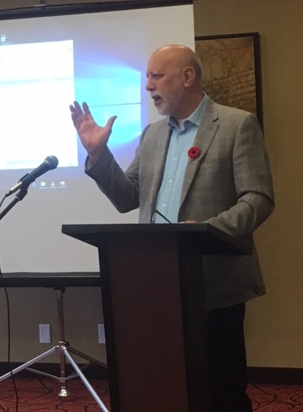

*Hon. Al Hawkins, Minister of Education and Early Childhood Development, talks about Government's commitment to implementing all 82 recommendations in the report by the Premier's Task Force during the NLFSC Biennial Meeting*

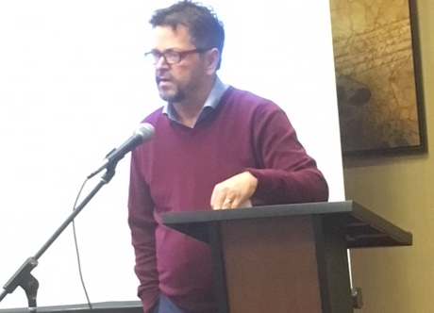

*“There are many innovative ideas and good things happening in schools across this province. It is important that we get that message out to the public,” says Dr. Kirk Anderson, Dean of Education, Memorial University*

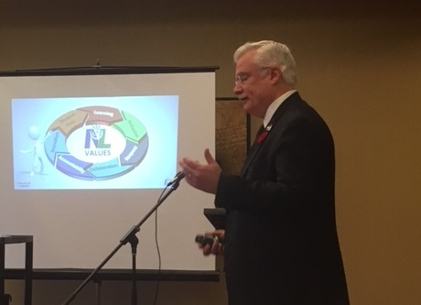

*Anthony Stack, CEO/Director of Education for the English School District, gives a PowerPoint presentation on the district's education goals and focus on learning*

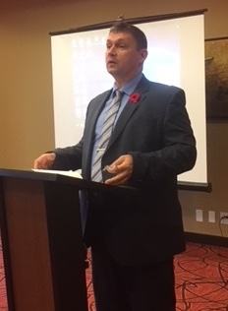

*“When schools and teachers are supported –students are supported. The province is in a challenging fiscal situation, but investing in education has to be a priority.”*

*“Smaller classes may be more costly, but they may have a better impact on student achievement.”*

*----Dean Ingram, President of the NL Teachers Association*

**The Newfoundland and Labrador Federation of School Councils Life Membership Award**

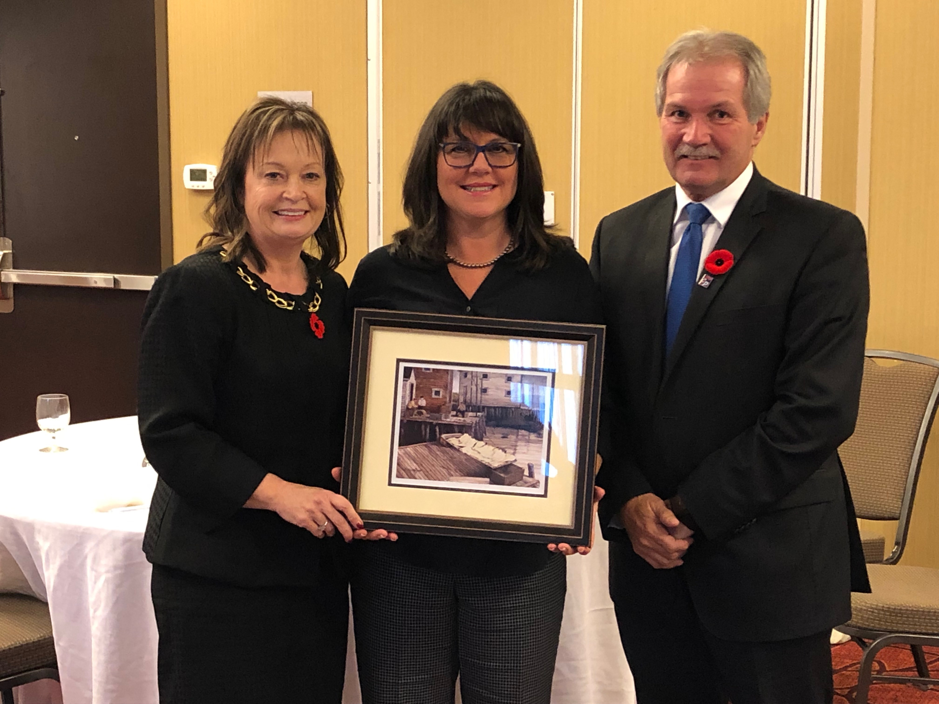

*NLFSC Executive Director Denise Pike and NLFSC President Don Coombs present former Treasurer Michele Peach (Centre) with the Life Membership Award*

As stated in the NLFSC Constitution:

“Life Membership in the Federation may be conferred at an NLFSC Meeting on any person for outstanding service in the Federation. Nominees for such membership must be endorsed by the Executive Committee of the Federation.”

To be awarded Honorary Life Membership is indeed an honor, but more than that it is recognition of a contribution to the Federation. Most of the progress and success of any

organization is determined by the interest, activity and unselfish devotion of its members.

Michele Peach is one of those committed members - and the recipient of the NLFSC Life Membership Award – as recommended and approved by the Executive.

Michele is being recognized for her outstanding contribution to NLFSC in the volunteer role of Treasurer.

For over 12 year our gracious and insightful Treasurer has applied her incredible background and expertise as a Chartered Professional Accountant to direct, oversee and manage the finances of NLFSC.

Michele also has a Bachelor of Commerce (Honours) Degree from Memorial University of Newfoundland, a Certificate in Local Government Administration from Dalhousie University and a National Advanced Certificate in Local Authority Administration from the University of Alberta.

In the midst of her demanding work schedule and other volunteer positions Michele always found time to manage the financials for NLFSC. She has been instrumental in advising and finding ways to help NLFSC continue our

advocacy, despite our diminishing operational grant.

Much of what we have achieved as a non-profit provincial organization would not have been possible without Michele’s expertise.

In her role of Treasurer Michele:

* Promoted the involvement of parents in NL’s public education system in a positive, effective, and long-lasting way.
* Actively contributed to the work of NLFSC and the significant advancement of its purposes as an organization.

Michele's contribution to the Federation is considered to have been of significan,t lasting importance to the inclusion and support of parents in NL’s public education system and the improvement of education for children in the province.

She has given her time generously to NLFSC without any expectation of reward.

We genuinely appreciate and value her continued commitment to volunteering with our organization.

Michele has been employed in the Newfoundland and Labrador public sector for 34 years, having worked with the Treasury Board Secretariat and the Office of the Auditor

General before joining the City of Mount Pearl 19 years ago where she has served as the City Treasurer, Director of Corporate Services and since 2011, as the Chief Administrative Officer. She retired from that position in 2017.

Michele’s dedication to helping others has earned her a number of prestigious awards. In 2012 she was awarded the Queen Elizabeth II Diamond Jubilee Medal for her leadership in a municipal finance project carried out in Sri Lanka following the devastating Indian Ocean tsunami.

Michele also received the Mike Badham Award for Outstanding International Volunteer Contribution from the Federation of Canadian Municipalities. She led six missions to Sri Lanka and hosted a study tour to Canada to help improve the financial management, taxation and property management in four Sri Lankan municipalities.   
   
Michele has been a dedicated and loyal member and supporter of the NLFSC Executive and has worked diligently to further the NLFSCs mandate for excellence in education for all children in Newfoundland and Labrador.

On behalf of the NLFSC membership we are pleased to present Michele with the Federation of School Councils Life Membership Award for

Outstanding and Dedicated Service to Education and to the Newfoundland and Labrador Federation of School Councils.

This award recognizes exemplary commitment to the NLFSC at both the local and provincial level.

Congratulations Michele! Thank you for everything you have done to help move NLFSC into the future.



**New Treasurer**

Following the presentation of the Life Membership award members of the NLFSC executive approved the appointment of Danica Allen to the position of Treasurer.

Danica holds a Bachelor of Business Administration degree with a major in accounting from St. Francis Xavier University and is a Chartered Professional Accountant.

She articled with Ernst & Young’s Assurance department in St John’s for four years working primarily on financial statement audits for clients across a broad spectrum of industries and reporting standards.   
  
Danica is currently the Manager of Accounting for the Piatto Pizzeria group, managing the

accounting and financial reporting for eight restaurants across Atlantic Canada.

The NL Federation of School Councils greatly appreciates Danica's willingness to share her expertise in business administration and experience as a Chartered Professional Accountant to assist our organization with its financial management.

Thank you for committing to fulfill the position of NLFSC Treasurer.



**Facts about NLFSC operations and funding**

The NLFSC Executive Board is comprised of volunteers and a part-time Executive Director who maintains our office, located in Avondale.

The Federation receives an annual operating grant of $21, 200 from the Department of Education.

We average between 150 – 200 phone calls per year from parents, councils, various government departments and agencies. The media, both provincially and nationally, contacts us almost weekly for our input on education issues and countless topics relating to the social, emotional and academic needs of students. Our opinion is also greatly valued by numerous other education stakeholders and agencies.

One of the key instruments of communication for the Federation is the membership listserv, which facilitates quicker information exchange. The listserv is used on a regular basis, to inform our membership of any changes relative to our schools.

It is also a great medium to gather immediate feedback on issues of concern and to share current information.

The Federation also has a Facebook, Twitter account and website. We try our best to keep all, previously mentioned, running on an operating grant of $21,200.00.

In 1999-2000, the Federation received an operating grant of $40,000; however, a year later it was reduced to $30.000. We continued to receive this $30,000 grant until the 2013 provincial budget when it was cut by $5,000, leaving us with $25,000 to run our organization. Despite a promise by the current Premier to increase our funding to $50,000 during the Liberal Leadership Debate on Nov. 18, 2016, hosted by the NLTA - the NLFSC grant was reduced to $21,200.00 in last year’s budget.

When comparing the funding provided by the NL Gov. to other Home and School and School Council Federations across Canada, the discrepancies are blatant.

* The Prince Edward Island Home and School Association receives a $75,000 operational grant for 52 schools and another $30,000 for grants such as parental involvement grant.
* The Nova Scotia Home and School Association receives a $35,000 Operational Grant and additional $20,00 to 30,000 for other initiatives.
* Ontario, BC and Alberta receives well over $100,000 and additional funding for parental involvement projects.

*(NLFSC has submitted proposals for*

*similar parental engagement projects to*

*government over the years)*

* Ontario also charges a membership fee of $15 per individual or family.
* New Brunswick receives approximately $30,000.

The NLFSC Executive will continue with its efforts to have our funding reinstated.

Additionally, the Executive also advocates for operational funding for each school council across the province.



**Curriculum Support Teachers**

The NLFSC membership is also very concerned about cuts to Curriculum Support Teachers (CST). In fact, cuts to this critical support was one of the main concerns expressed by school councils at the 2016 NLFSC Biennial Meeting.

Services provided by a CST were once in many schools, and proved to be a tremendous benefit to children who were struggling with various areas of the curriculum. Unfortunately, when a school loses teaching units, the CST is often one of the first programs/services to go.

Our current education policies require a child to have a diagnosed disability before they are

eligible to receive support from an Instructional Resource Teacher, however there are many children struggling academically that do not meet these criteria. These children, who often don't perform at grade level in reading and math, fall between the cracks. A CST would assess and work with these struggling children and provide the support they need to "catch up" without having to wait and go through the assessment process. (Many of these students need support for a short period of time or just need that extra teaching to help them grasp concepts).

The support of a Curriculum Support Teacher, enabled many children, who were struggling in a subject area and in some cases grades behind their peers, to experience academic success.

NLFSC recommends government allocate a specific allocation for Curriculum Support Teachers.



**Cristmas Greetings from the NLFSC**

**Executive**

Christmas… that magic blanket that wraps itself about us, that something so intangible that it is like a fragrance. It may weave a spell of nostalgia. Christmas may be a day of feasting, or of prayer, but always it will be a day of remembrance -- a day in which we think of everything we have ever loved.

The NLFSC Executive would like to take this opportunity to extend good tidings to you and your family as we celebrate this season of giving.

Please pass along our warm wishes to your school communities for successful holiday fundraisers, community giving events, and

musical celebrations for which I’m sure many of you are busy preparing.

On behalf of the NLFSC Executive

(Don, Dave, Lori, Ruby, Denise and Danica)

**Merry Christmas and a healthy and happy New Year**

----------------------------------------------------------

The Cuffer is a benefit of membership in the Newfoundland and Labrador Federation of School Councils.

Annual membership dues are based on school enrollment. Individual subscriptions are available at $15 per year.

The views expressed or implied in this

publication are not necessarily official positions of the Federation.

The mention of any program, organization,

resource, product, person, place, or school does not constitute an endorsement by NLFSC.

Editor: Denise Pike

Proof Reader: Lori Barry

NLFSC Contact Information

P.O Box 23140

St. John’s NL

A1B 4J9

Tel: (709) 764-8993

Email: nlfsci@gmail.com