The Cuffer Jan/Feb 2020
A newspaper for School Councils in Newfoundland and Labrador

Message from the President

Hello Members!
By the time this edition of the NLFSC newsletter reaches you, I hope the effects of Blizzard 2020 is nothing more than a light snowfall, and you can retire your shovels to the shed. To say it’s been a busy first month is an understatement.
I would like to personally thank all the essential workers who stayed on site shift after shift, without any relief to provide necessary services, and take care of others. Hats off to the snow crews and electrical crews, firefighters and other emergency workers who worked long, hard hours…. the list goes on and on. I also commend my fellow Newfoundlanders and Labradorians who pulled together to help in any way possible during the storm. The acts of kindness by individuals and businesses were endless.
The state of emergency provided the opportunity to show what it means to be a good neighbor. It was a shining example of goodwill, kindness, and resilience. It was the worst of storms, but in many ways…. It was the best.

This is also a good time for me to commend our School Principals and District Personnel for the times when they have to make the difficult decision to delay school opening or close for a day because of poor weather.
Closing a school is a tough call. The decision often requires hours of preparation and discussions with local officials, road crews, bus operators and drivers, and meteorologists. Most school leaders say they take a better-safe-than-sorry approach, but it often results in phone calls, emails and nasty Facebook posts from irate parents.
Closing a school can is never an easy decision, and weather forecast can change or be wrong, but student safety always takes precedence over any inconvenience that may result from these challenging choices.

On another note, on January 16th I met with Eldred Barnes, Associate Deputy Minister of Education and Early Childhood Development, for an update and PowerPoint presentation on the Education Action Plan. I am very pleased with the strategies and number of recommendations that have already been implemented, or are underway. NLFSC believes the recommendations mark the beginning of great change and improvements in the education system. We are fully aware the action plan specifies timelines for the implementation of the recommendations, and we are committed to doing everything in our power to ensure these timelines are met and promises are kept.
It is the position of the NLFSC that education is an investment in the future of this province and must remain a priority.

I am looking forward to celebrating Teacher/Staff Appreciation week from February 9- 15. Teachers and school staff play a critical role in the lives of our children. It takes a lot to give a lot. Patience, kindness, and understanding is constantly required to nurture young minds and personalities. Please take time to show appreciation to your teachers and school staff.

Sincerely,
Don
don.coombs@easternhealth.ca

Here are a few ideas and suggestions to assist with the celebration of TSAW week:

Monday - Hang a “We Love Our Teachers/Staff” banner on the front of the school. Place a red apple with a note from the Home and School Association/School Council in each mailbox or on each desk.
Don’t forget the bus drivers and custodians. - Make a daily draw for a donated prize.
Tuesday - Hang a collage made of photos of teachers/staff and students at work and play and decorate the halls with balloons and

paper apples on which the students have written stories, poems or drawn pictures. Serve coffee and treats in the staff room. - Daily draw.
Wednesday - Place flowers in staff room. Serve a buffet lunch. Be sure to arrange for supervision so all teachers and staff can attend. - Daily draw.
Thursday - Have cheese platters and a fruit basket in the staff room. Give each staff member a bag filled with pens, notepaper, etc.- Daily draw.
Friday - Hold a Teacher/Staff Appreciation Tea/lunch. -Daily draw or draws depending on the number of prizes that have been donated by local businesses. - Raffle grand prize winner draw.

The celebrations and ideas don’t need to be costly. A heartfelt homemade card, notes on classrooms doors, and banners also go a long way in making your school staff feel appreciated. An email message or face-to-face “Thank you” will never be forgotten.

For more ideas please visit our Facebook page and take a look at the photos, submitted by members, during past TSAW celebrations.

The following pictures are just a few of the
wonderful ideas, which showed appreciation to teachers and schools’ staff.

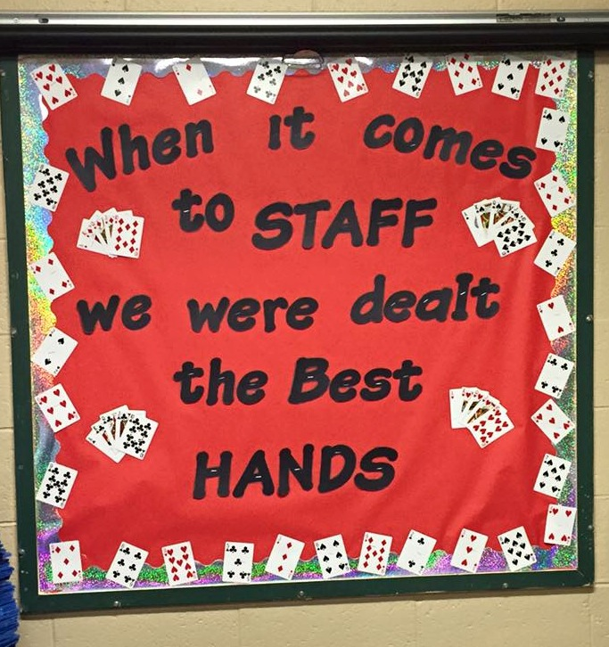

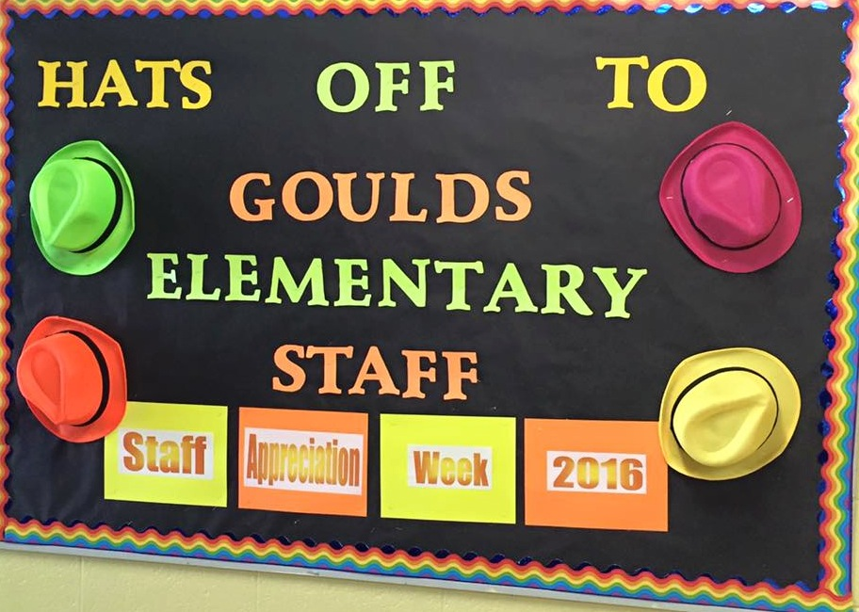

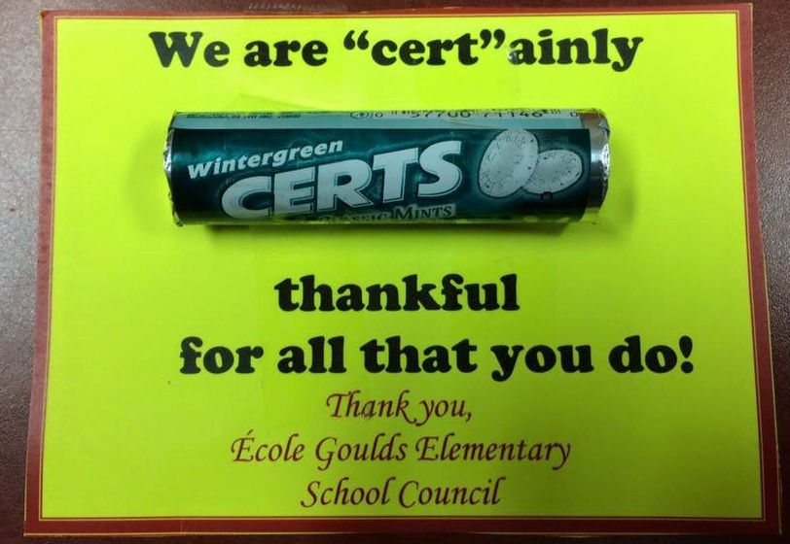

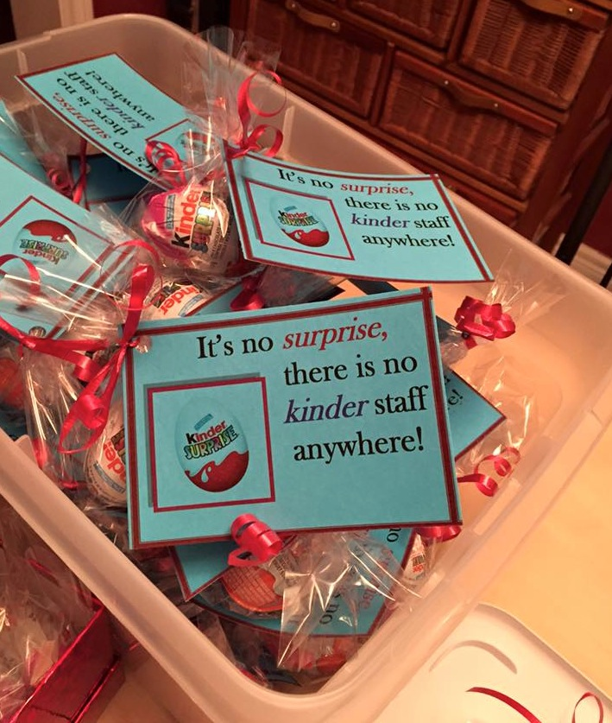

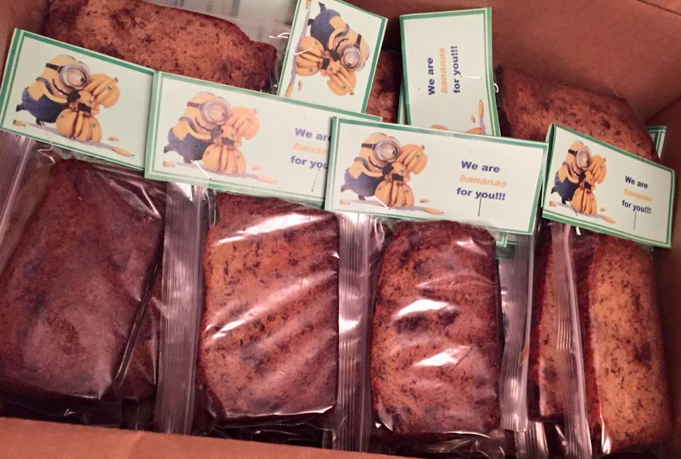

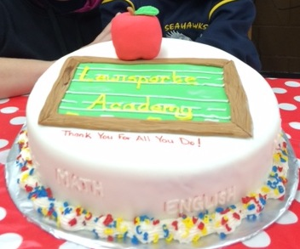

Membership Renewal

Thank you to the school councils that have renewed their membership! We greatly appreciate your support.
To those who have not, please do so as soon as possible

Your continued membership will help support our mission to advocate for excellence in education for all students in Newfoundland and Labrador.
(Form attached)

Prebudget Submission
The Newfoundland and Labrador Federation of School Councils is currently preparing a
Pre-budget Submission to government outlining the importance of investing in education.
NLFSC believes the best solution to our province’s pressing economic and social challenges lie in providing our children with a quality education.
These children will one day be our workforce, business-owners,

and political leaders. Education affects everyone and it provides every child with an opportunity to achieve a prosperous future.
NLFSC encourages parents and school councils to share your views with your MHA and Government on how to best invest in education.
The voice of parents and councils can often precipitate effective change!

EDUCATION WEEK
March 8-14, 2020
Education Week has always been about
celebrating education and the importance of learning. The theme for this year is
“2020 Vision.”
Education Week can be an enriching
experience for students, teachers and
parents. All teachers and school councils are encouraged to continue to observe Education Week with their students. All students have much to contribute and would grow and learn from involvement in Education Week activities.

2019 Pink Shirt Day

Bullying is often a problem in our schools, workplaces, homes, and over the Internet. On February 26th we encourage School Councils, across the province, to wear something pink to symbolize that we as a society will not tolerate bullying anywhere.

Pink Shirt Day began in Nova Scotia in 2007, when two Grade 12 students - David Shepherd and Travis Price - stood up to defend a young male person who was bullied because he was wearing a pink shirt during the first week of school. The students took a stand by wearing pink shirts to show
solidarity, and handing out pink shirts to their classmates.

Pink Shirt Day has since become a national campaign aimed to raise awareness about the power to prevent bullying.
Newfoundland and Labrador will use this day to raise awareness of the negative effects of bullying and show that any form of bullying will not be tolerated.
You too can join the sea of pink! NLFSC invites you to take the opportunity to address the issue of bullying with your children or teens, by wearing pink, planning an event or activity or just having an intentional conversation.

2020 Freedom to Read Week

Freedom to Read Week (February 24 – March 2) is an annual event that encourages Canadians to think about and reaffirm their commitment to intellectual freedom, which is guaranteed them under the Charter of Rights and Freedoms.

Freedom to Read kit is suitable for librarians and educators. It includes a poster, extensive background material on freedom to read and some classroom exercises. For more
information visit their website at http:/.www.freedomtoread.ca/kits.index.htm

Counsellor of the Year

Congratulations to Gerard Lowe, Guidance Counsellor at Corner Brook Regional High who was recently names the Nation School
Counsellor of the Year by by the Canadian Counselling and Psychotherapy Association.

Mr. Lowe was chosen for his commitment to improving the lives of students, developing community initiatives for youth at risk and
advocating for changes to help youth
experiencing barriers in their lives.

He is a strong advocate and supporter of the LGBTQ+ students and community. Around 10 years ago he helped start the Corner Brook Regional High Pride Alliance. He
also chaired the first provincial high school LGBTQ+ conference, held in the province.

Mr. Lowe is the founder of the Art of
Conversation, Confidence and Kindness Club. The club encourages kindness and provides students a space to engage with peers and participate in different activities.

He has also provided supervision to interns on a regular basis - demonstrating leadership that helps the counselling profession
maintain core competencies and grow.

Mr. Lowe will receive a plaque and a $300 cash prize at the Canadian Counselling and Psychotherapy Association's annual
conference banquet in Edmonton in May.

On behalf of NLFSC executive and
membership, thank you for your
commitment and endless
unpaid hours given to the social and
emotional health of the students at your school. Please accept our sincerest
congratulations on this great achievement and prestigious award.

NLFSC Regional Meetings

The NLFSC Executive will be holding
regional meetings with school councils across the province next fall. We are in the planning stages and no dates or locations have been finalized, however the meetings will begin with a Meet and Greet on Friday night, to half day meetings on Saturday.
The agenda will focus on the role of school councils, the power of school councils, and how to network and influence the decisions-makers in education.
There will also be an Open Mike Session to
allow school council members to speak and share ideas.
We will continue to update our membership on the plans, and we welcome your input, feedback, and suggestions.

The Role of School Councils

Since the beginning of the school year, NLFSC has received 42 phone calls and 18 emails regarding the role, function, and do’s and don’ts of school councils. It is clear that there are mixed messages being passed along to administrators, teachers, parents, and community representatives.
There have been various interpretations on the role of a school council, especially when it comes to issues of school closures (due to enrollment or reorganization),
consolidations, student safety and
maintenance. School councils are mandated organizations composed of parents, teachers, and community members (and sometimes
students) that facilitate parental participation in our schools. Sections 25 and 26 of the Schools Act, 1997, provide the legislative authority.

As stipulated in the Schools Act, 1997
Section 26(2), the functions of a school council are to:
represent the educational interests of the school; advise the board on matters of concern to the school and the community.

As stated in the Schools Act, 1997 Section 26(1): The purpose of a school council is to develop, encourage and promote policies, practices and activities to enhance the quality of school programs and the levels of student achievement in the school.
The School Council Handbook says: School councils are accountable to their school and to the school community. They are responsible for doing what is in the best interest of the school, and what is in the best interest of all students collectively.

Councils are also responsible for “advising the board on matters of concern to the school community”. Therefore, NLFSC believes there will be some circumstances in which school councils should not only engage in discussions regarding student safety, school maintenance, and school closures and consolidation, but also forward any concerns to the school district.The handbook also says council members should regularly seek feedback from their respective groups on the teaching and learning environment of the school and issues which impact this environment.

The principal is responsible for the direct management of the school and, therefore, has responsibility for the development and implementation of school-based policies. School councils act in an advisory capacity whereby they advise on how to implement such policies.
School councils do not engage in discussions on individual teachers, students, parents or guardians. School Councils also do not to engage in discussions relating to personnel or administrative issues.

The Schools Act 1997 is also clear the Principal of a School cannot be the chair of its school council, nor does the principal have power to limit topics of discussion, aside from the above noted topics.

We will continue the dialogue and discussions on the role, responsibilities, function and purpose of a school council with our education partners.
Should your council have any concerns regarding the above, please contact the NLFSC office at 764-8993 or email nlfsci@gmail.com

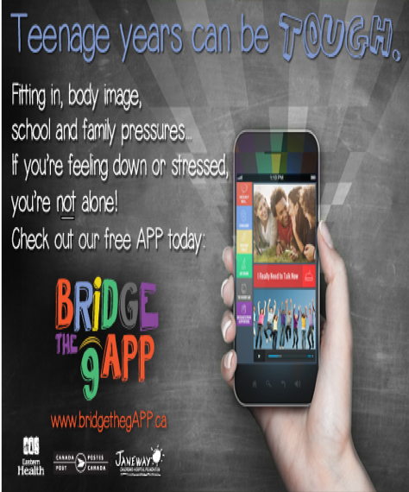

Mental Wellness App

Bridge the gAPP is a mobile app developed by Eastern Health NL that supports and promotes mental wellness in youth and adults.
The best thing about it is its accessibility. From a computer, tablet or a phone in your pocket, you can instantly access content that can provide advice, inspiration, assurance, or direction for finding additional supports when you need it the most.

Mental health is essential to overall health and wellness. When we have good mental health and wellness we are able to handle life's stressors, build strong relationships, and lead productive and fulfilling lives.
Depending on what you are looking for you may want to visit Bridge the gAPP for youth (ages 13-18), Bridge the gAPP for adults (18+) or visit the service directory to

connect to local services right here in Newfoundland and Labrador.
The apps are available for download on the
App Store or Google Play. Both apps and a
mental health and addictions service directory can also be accessed at www.bridgethegapp.ca.

Mental Health and Addictions

The importance of healthy mental and physical
development for children cannot be
overestimated. Many people recognize the
importance of a healthy childhood, but few
understand the critical part played by mental
and emotional problems and how important and
harmful they can be for children and youth
throughout the growing years. As many as one
in four young Canadian adults between the ages
of 15 and 25 suffer from some degree of
depression, substance dependence or anxiety
disorder.

NLFSC believes that: unless these
problems are treated appropriately and
effectively, these young people never reach their full
potential and will underachieve their entire lives.
Advocating for supports for Mental Health
Issues and Addictions among our youth has been two of
the main goals of the NLFSC for many years.
We often hear from parents who are searching
for Mental Health and Addictions counselors
for their children.

NLFSC believes more Mental Health providers, who specialized in children and adolescents, and more Treatment Centres are needed in this province. The NLFSC executive will continue to lobby government for these supports.
In the meantime, in an attempt to help our membership, parents, and students we offer the following information on Mental Health and Addiction Treatment Centres in NL.

Recovery Centre
The Recovery Centre is a 19-bed provincial inpatient withdrawal management service located in Building 532, Pleasantville. The service is available to anyone 16 years and older, who is intoxicated or experiencing withdrawal from alcohol, drugs and/or gambling. Admissions can be self-referrals or through hospital emergency units, health professionals and community agencies. The length of stay is determined by individual need.
The program focuses on stabilizing individual’s physical and psychological health through the withdrawal process. An Addictions Counsellor is available to meet with clients of the Recovery Centre for assessment, crisis counselling and discharge planning purposes. Clients also have access to in-house education and group sessions, as well as, onsite self-help meetings. The
non-threatening, non-judgmental environment encourages clients to begin a recovery process.
To get started (you don’t need a referral, but you do need to call yourself):
Call 709-752-4980 or 1-877-752-4980.

Humberwood Treatment Centre
Humberwood is a live-in, non-medical treatment Centre located in Corner Brook.

If you are a resident of Newfoundland and
Labrador and over the age of 19, Humberwood may be able to help with your drug, alcohol and/or gambling concerns.
Humberwood offers a structured program that focuses on your needs through
individual, group and family counselling. There are private rooms and the usual stay is 21 days.
Most people go to counselling or other
programs first, but if you feel that you need residential services, ask your physician, nurse or counsellor about Humberwood.
For more information:
- Call 709-634-4506
Click: https://westernhealth.nl.ca/index.php/programs-and-services/services-a-z/humberwood-treatment-centre

The Grace Centre
The Grace Centre is a live-in addiction treatment Centre located in Harbour Grace. If you are a resident of Newfoundland and Labrador and over the age of 18, The Grace Centre may be able to help with your drug and/or alcohol concern.
The Grace Centre offers a structured
program that focuses on your needs through individual, group and family counselling. There are 18 private rooms and the usual stay is 28 days.
Most people go to counselling or other
programs first, but if you feel that you need residential services, ask your physician, nurse or counsellor about The Grace Centre. They can assist with a referral.
To learn more:
- Video Tour
- Brochure (pdf, 2016)
- Frequently Asked Questions
- Client Handbook
- Photo Gallery
- Telephone: 709-945-4500
Recovery Centre, St. John’s

Tuckamore Treatment Centre
Tuckamore is a live-in treatment Centre for 12 to18 year old’s who have complex mental health concerns.
Tuckamore is located in Paradise and the average length of stay for young people is between 6 - 12 months. The program
includes individual, group and family
counselling as well as life skills training, recreation, and art and music therapy.
Tuckamore provides a safe home-like
environment, a school area, a multipurpose room, a physical fitness area and an
apartment for family visiting overnight.
You can also ask your physician, nurse,
clinician or social worker about other
supports for youth in your area (i.e.
counselling).
For more information:
- Video
- Brochure: Youth Treatment Centre Brochure (2014)
- Call 709-752-3914

Hope Valley Treatment Centre
Hope Valley is a live-in treatment center for 12-18 year olds in the province who are concerned about their drug or alcohol use.
Hope Valley is located in Grand Falls-Windsor and the average stay is 3-4 months. The Centre houses up to 12 youth and
provides a variety of services such as detox, counselling, schooling and life skills
training.
Please discuss Hope Valley with your health care provider or contact us at 709-292-8360 to help decide if this service is right for you or a loved one.
For more information:
- Caregiver Questionnaire
- Youth Handbook
- Parent/Caregiver Handbook

Out of Province Treatment Policy
The Department of Health and Community Services has guidelines for the application process of Out-of-Province (OOP)
addictions treatment and specialized mental health services. Treatment options within the
province must first be fully utilized and/or deemed not appropriate to meet specific
client needs before funding approval for
out-of-province treatment is provided.

For more information please refer to the Out-of-Province Treatment Guidelines (307 KB)

HealthLine 811 or TTY 1-888-709-3555
The Provincial HealthLine is a free, confidential, 24-hour telephone line, staffed by experienced registered nurses in our province who can offer health advice, information and connect you to resources and local services.

Warm Line 1-855-753-2560 or 753-2560
Need someone to talk to? The Warm Line offers non-emergency, non-crisis telephone support for people in the province who are living with
mental health issues. CHANNAL’s trained peer supporters are non-judgemental and have firsthand knowledge. The Warm Line is
available between 11:00 am and 11:00 pm, 7 days a week.

Gambling Help Line 1-888-899-HELP (4357)
The Gambling Help Line is a free, confidential service available province-wide, 24 hours a day. If you or a family member have a gambling
concern, please call for information and support.

Smokers’ Helpline 1-800-363-5864
The Smokers’ Helpline is a free, confidential service providing information, resources, support and motivational counselling while you are working toward being smoke free. Connect by phone, text, email or Live Chat. To get started, please call or go online at:
https://wwww.smokershelp.net

Kids Help Phone 1-800-668-6868
Kids Help Phone is always there for you. No matter what you want to talk about, they’re available to listen. No judgment, totally private, 24/7. Call or go to https://kidshelpphone.ca/ to connect by text, email, Live Chat, download our free
“Always There App”, or learn about BroTalk.

First Nations & Inuit Hope for Wellness Help Line 1-855-242-3310
The Help Line provides immediate culturally competent, telephone crisis intervention
counselling support for First Nations and Inuit 24 hours a day.

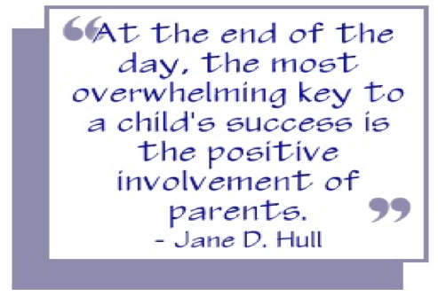

First Vaping-Associated Illness Confirmed in Newfoundland and Labrador

The Provincial Government’s Chief Medical Officer of Health has confirmed a probable case of vaping-associated lung illness in Newfoundland and Labrador. The person affected became ill in late 2019, and was hospitalized. They have since recovered.
The substance of concern is a cannabis product,

E -cigarettes should never be considered the first choice for smoking cessation because of the risks and given the extent of the current outbreak of severe lung disease, e-cigarettes should be avoided at the present time.
E-cigarettes are very popular with young people. Their use has grown dramatically in the last five years.
No matter how it's delivered, nicotine is harmful for youth and young adults.

Governor General’s History Award for Excellence in Teaching
Each year, Canada’s History Society recognizes 6 teachers for innovative approaches to teaching Canadian history. The 2019 recipients will be awarded:
•An individual cash prize of $2500;
•A $1000 cash prize for the recipient’s school;
and a trip for two to Ottawa to attend the awards ceremony at Rideau Hall, the Canada’s History Forum, and the History Makers celebration dinner.
If you or a teacher you know makes history come to life in the classroom, submit a nomination or apply online today! Applications are due April 1, 2018
CanadasHistory.ca/GGAward
If you have any questions about the award or application, please contact Joanna Dawson.
Past applications can also be reactivated.
Facebook:https://www.facebook.com/CanadasHistory/posts/1648414315217536
Email:jdawson@canadashistory.ca
Phone: 1-866-952-3444 (Ex:225)

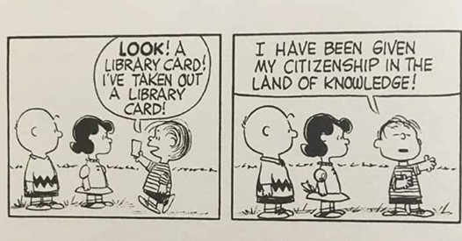

National Nutrition Month

March is Nutrition Month across Canada and this year’s theme “More than Food!” encourages Canadians to consider not only what they
eat, but how they eat too. Registered dietitians play a
critical role in helping people eat right, their way, every
day.

In 2019, Health Canada released the new
Canada’s Food Guide. During the revision
process, Dietitians of Canada advocated strongly that Health Canada include considerations
beyond nutrients and talk about how we eat, not just what we eat in the new guide. This included consideration of food literacy, food culture and traditions, food availability and sustainability.

The 2020 Nutrition Month campaign recognizes
the Healthy Eating Habits that are part of the new Canada’s Food Guide http://www.canada.ca/foodguide

NLFSC Executive Contact List

PRESIDENT
Don Coombs
Phone: 709-589-5995
Email:Don.Coombs@easternhealth.ca

VICE PRESIDENT
David Hillier
Phone: 709-290-4907
Email:davidhillier@gmail.com

Vice President
Craig Tavenor
Cell: 709 687-9244
Email: cttavsmail@gmail.com

SECRETARY
Lori Barry
Cell: 709-290-4399
Email: a.lori.barry@gmail.com

Past President
Ruby Hoskins
Cell: 567-1466
E-Mail: rubyhoskins63@yahoo.ca

Treasurer
Ashley McCarthy

The Cuffer is a benefit of membership in the Newfoundland and Labrador Federation of School Councils. Annual membership dues are based on school enrolment. Individual
subscriptions are available at $15 per year.

The views expressed or implied in this
publication are not necessarily official positions of the Federation.
The mention of any program, organization,
resource, product, person, place, or school does not constitute an endorsement by NLFSC.

Editor: Denise Pike, Proof Reader: Lori Barry
Email: nlfsci@gmail.com

NLFSC Contact Information
P.O Box 23140
St. John’s NL
A1B 4J9
Phone:709-764-8993

