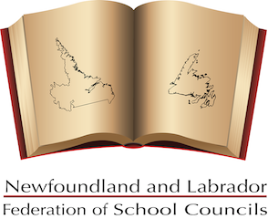

``

Newfoundland and Labrador Federation of School Councils

Recognized as the advocacy voice in public education, NLFSC presents the School Council perspective to government and education organizations in NL.

Mailing Address: Tel:709-764-8993
P.O. Box 23140 E-mail:nlfsci@gmail.com
St. John's, NL
A1B 4J9

NLFSC Atlantic Caucus Report

NLFSC is pleased to have the opportunity to share this report. It not only highlights the dedication, passion, and countless hours of volunteerism by the NLFSC Executive (Don, David, Craig, Lori, Ruby and Ashley) - but also reminds us of how much work we are doing, and what we have accomplished, despite our dwindling budget of just $21,200 per year.

The Newfoundland and Labrador Federation of School Councils (NLFSC) is the provincial umbrella group for parents, teachers, high school students (where applicable), and community supporters who are committed to enhancing the quality of school programs and improving the levels of student achievement in our schools. The Federation provides School Councils and parent groups with a voice on educational issues and encourages parental involvement at all levels of education.

NLFSC works to strengthen communication between parents, school councils, government and the school district. NLFSC is often consulted on issues and proposed changes, and is a member of numerous provincial education committees. In addition, we maintain an on-going liaison with provincial partner groups to foster mutual trust, cooperation and support.

NLFSC is a non-profit organization governed by an elected volunteer Board of Directors. Membership consists of school-based parent groups, who are represented through School Councils, and Home and School Associations. Membership is optional and renewed annually.

Education gives every child an opportunity to succeed and is society’s greatest equalizer. One of the NLFSC’s primary goals is to engage parents as much as possible in their children’s learning and as such, we encourage all school councils to make this a priority as well. Learning begins at home and parents are their child’s first teacher. NLFSC and School councils can play a major role in helping this continue as children progress at every grade level.

Operating Grant/Funding

NLFSC receives an annual operating grant of $21,200 from the Department of Education. Our part-time Executive Director maintains our office and the day-to-day operational responsibilities.

In 1999-2000, the Federation received an operating grant of $40,000; however, a year later it was reduced to $30.000. We continued to receive this $30,000 grant until the 2013 provincial budget when it was cut by $5,000 - leaving us with $25,000 to run our organization. Despite a promise, made by the current Premier, to increase our funding to $50,000 during the NLTA Leadership Debate on Nov. 18, 2016 – the NLFSC grant was reduced to $21,200 in the 2017 provincial budget (In addition to our operational grant, NLFSC usually receives $5,000 from Government to assist with the cost of our Biennial Meetings).

Membership

There are approximately 260 schools in Newfoundland and Labrador (this includes 6 private and 3 native schools). Of those eligible (245) - 228 school councils were in good standing with NLFSC at the end of the 2018-19 school year. Membership fees are 45 cents per student at a maximum of $75, per school, each year.

Supporting our Membership

The following information describes some of the work and activities carried out by NLFSC - and issues and concerns from parents, teachers, and school councils that we seek to address every year.
NLFSC averages between 150 – 200 phone calls, per year, from parents, councils, various government departments and agencies. The media, both provincially and nationally, contacts us at least once a month for our input on educational issues and countless topics relating to the social, emotional and academic needs of students.

During the past 2018-19 (and current school year) NLFSC did our best to provide answers and guidance on the following concerns:

School/education resources, bullying, mental health and addictions, school council role and structure,
student assistant time, allocations for teachers, administrators and guidance counselors, 1.6 km bus policy, violence in school, parental involvement in education, school closures, school maintenance, cyber bullying, inclusive education, class size, background checks on school volunteers, funding for travel to NLFSC meetings, vaping and smoking, numeracy and literacy, truancy, curriculum support and instructional resource teachers, teacher morale, pre-budget submission suggestions and challenges and personality conflicts on school councils.

Finding solutions usually requires multiple phone calls, texts, emails, as well as a great deal of discussion, mediation, research and communication.
We do not always find a solution that is satisfying to all, however most of the time we are able to bring a sense of calm to a volatile situation.

Listserv
One of the key instruments of communication for NLFSC is the membership listserv, which facilitates quicker information exchange. The listserv is used on a weekly basis, to inform our membership of any changes relative to our schools. It is also a great medium to gather immediate feedback on issues of concern and to share current information.
From September 6, 2018 to September 13, 2019, NLFSC sent 28 emails/messages out to members. We
requested and received feedback on a number of issues including our 2019 pre-budget submission, teacher allocations and student assistant time.
NLFSC also has a facebook page, twitter account, and website. NLFSC sends out 6 – 10 Media Releases, throughout the year, on a variety of education topics.

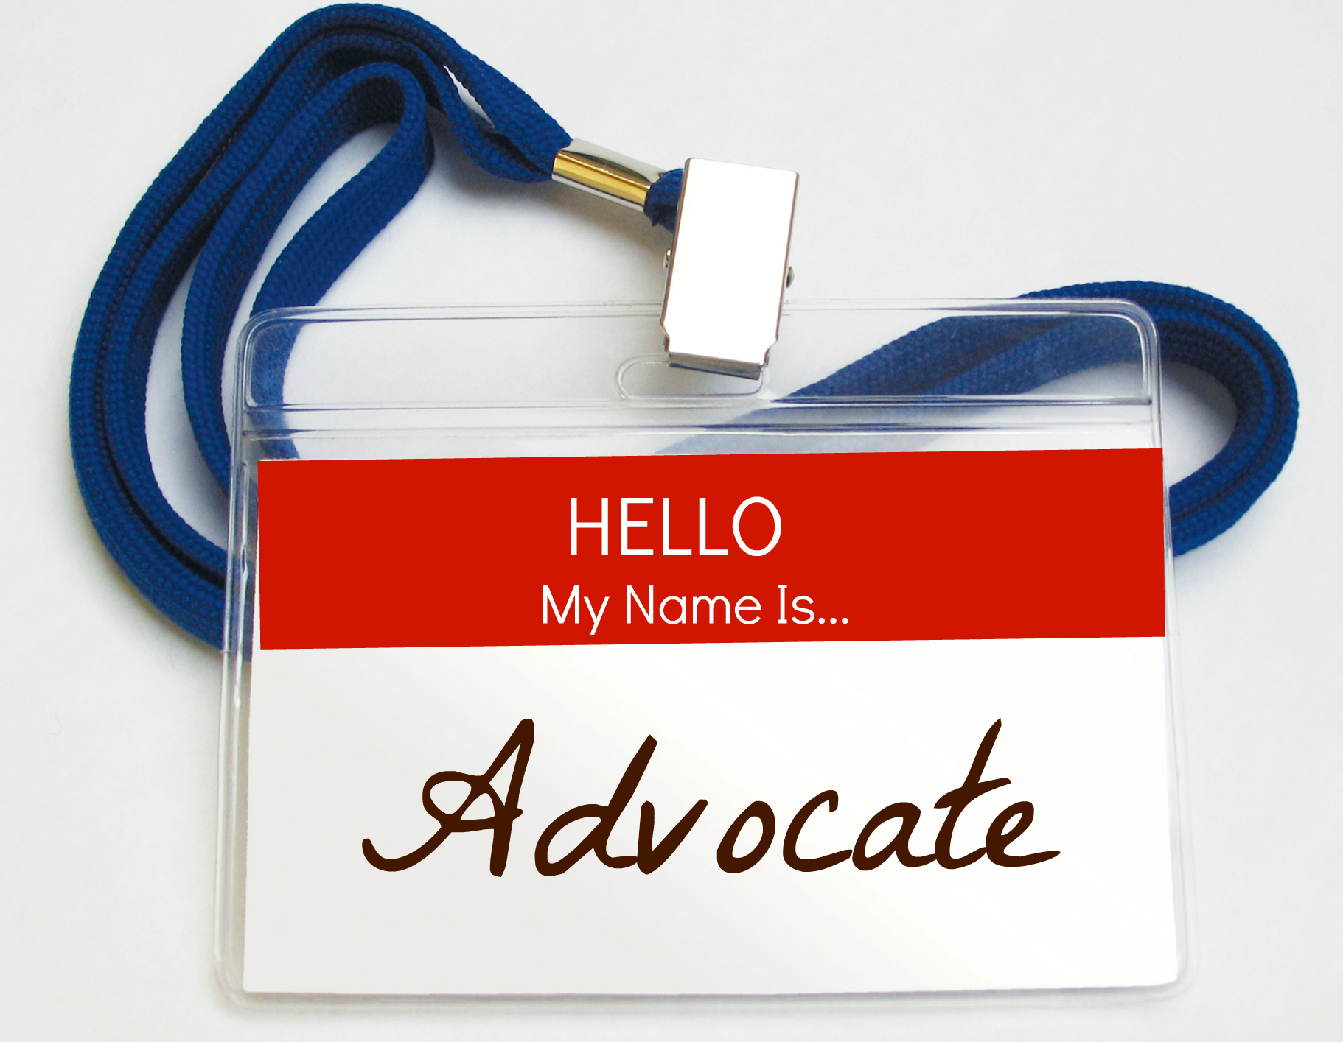

Election of Officers

Each year an election of officers (2) for the NLFSC board takes place. During the last school year (2018-19) we held our first electronic election. This allowed all school Councils to cast their ballot – as opposed to only those who could attend and vote at our Biennial Meetings.

The NLFSC Nomination Committee (comprised of former school council representatives) oversees the voting and counting of ballots.
Members of that committee also oversee the judging of the School Council Person of the Year Award, which is issued annually to a school council member who has demonstrated outstanding dedication to their local school.

BOARD STRUCTURE

NLFSC’s Board of Directors consists of the elected officers of the Federation, plus the Treasurer, and Immediate Past President. The current officers are: President Don Coombs; Vice President Craig Tavenor; Vice President David Hillier; Secretary Lori Barry, and Past President Ruby Hoskins. The Treasurer, Ashley McCarthy, is an appointed and non-voting member of the Executive.
The Executive Director communicates daily (email, phone, text) with the President and executive. The executive holds 2 face-to-face meetings per year, and 3 teleconference calls.

Reports

Each year NLFSC submits a pre-budget document to government for consideration. Our report is based on education priorities and goals set by the executive and membership. We provide our membership with an Annual Report, which details our advocacy initiatives, meetings, goals and finances. NLFSC also submits input and reports on other issues relating to education and the well-being of students (Premiers Task Force, Review of Inclusion Model)

Newsletter
The NLFSC’s newsletter, The Cuffer, is sent out to members five times a year. It is an important part of communicating with our membership and provides our membership with updates on changes taking place in education. It also offers tips and advice on the role and effectiveness of a school council. We often include information from our education partners such the Alliance for the Control of Tobacco NL (ACT), Kids Eat Smart Foundation NL, School Milk Foundation and NL School Lunch Program.

Provincial Budget

Each year, the President is invited (by the Premier’s Office) to a Provincial Budget Lock-Down at the Department of Education for a briefing on the fiscal impact to education. The President is also invited to the House of Assembly for reading of Provincial Budget.

Teacher/Staff Appreciation Week

Every year NLFSC recognizes educators and school staff for educating and nurturing our students during Teacher/Staff Appreciation Week. NLFSC also sends out a media release and listserv message recognizing our councils for their time and dedication to schools during the provincial Volunteer Appreciation Week

Provincial Meetings and Forums

Each year NLFSC is asked to participate in numerous provincial forums and committees. Due to limited funding, we often cannot attend in person, but participate via teleconferencing.

Some of the meetings and forums attended and participated in include:

- NL School Food Environment Assessment
- Launch of the Immigration Action Plan.
- Director of the Recreation and Sport Division
- Stakeholder Forum on the Legalization of Cannabis
- Mental Health and Addictions Action Plan
- Capacity Building Workshop and Working Session on Individualized Funding by the Coalition for Community Living
- NLTA Teacher Induction Ceremony
- Provincial Planning Forum on Food Security
- Premier's Round Table on Immigration
- Alliance for the Control of Tobacco (ACT)
- Implementation Committee for the Premiers Task Force

The NLFSC Executive meet with representatives of the English School District, various government departments, NLTA and the Minister a couple of times each year. During the 2018-19 school year members of the executive met with the Minister of Education on 3 occasions.

Current Provincial Education Initiatives

One of the most important ongoing initiatives to education was an evaluation of the education system by the Premier’s Task Force on Improving Education Outcomes. The final report resulted in 82 recommendations needed to improve the education system in NL.
It is important to note that many of these recommendations emulated resolutions, put forth and passed by the NLFSC membership, at our Annual Meetings.

The NLFSC executive met with members of The Premier’s Task Force, and also submitted a detailed document, expressing the concerns of our membership.
The final report entitled “Now is the Time” promised to make changes to our education system, that would improve the learning experience for all students, by focusing on these 9 key areas:
1. Student Mental Health and Wellness
2. Inclusive Education
3. Mathematics
4. Literacy
5. Indigenous Education
6. Multicultural Education
7. Career and Co-operative education
8. Early Years
9. Teacher Education and Professional Development.

Some of the recommendations by the Premiers Task Force have been implemented with more changes to come.
We are fully aware the action plan outlines specific timelines and responsibilities for implementation of the recommendations, and we are compelled to do everything in our power to ensure these timelines are met and promises are kept. In good conscience we could do nothing less; our children need and deserve nothing less. NLFSC has met with the Associate Deputy Minister - responsible for the implementation of the recommendations - on several occasions. Updates on changes and improvements to education are provided to NLFSC on a regular basis.

School Council Handbook

The Department of Education and Early Childhood Development is currently updating the school council handbook. NLFSC was asked to provide suggestions. We also provided feedback on a draft video which explains the role and purpose of a school council.

Review and Changes to the NL Schools Act

Department of Education and Early Childhood Development held public consultations, and one-on-one discussions with key stakeholder groups, such as NLFSC, to explore potential amendments to the School Act legislation.

Autism Action Plan

The Provincial Government has committed to provide increased services and supports for individuals living with autism spectrum disorder. The plan consists of 46 actions which will be completed by March 2021.
Focus areas include:
- Awareness, acceptance, diagnosis and assessment of autism spectrum disorder;
- Support for individuals, families and caregivers living with autism spectrum disorder;
- Evidence-based treatment and management of autism spectrum disorder;
- Education for children and youth living with autism spectrum disorder;
- Living with autism spectrum disorder in the community; and
- Professional learning and development in autism spectrum disorder.
- The province includes improved access to home and community support services by eliminating the criteria of IQ 70 from the current eligibility requirements. This means eligibility for support services will be based on functional need only.
- The Plan will also see the creation of two new programs that will ensure seamless supports across the lifespan. The Provincial Autism Services Program will expand Applied Behaviour Analysis (ABA) programming beyond Grade 3 for children and youth up to age 21 and the Supporting Abilities Program for adults will encourage supportive employment opportunities.
- JASPER (Joint Attention Symbolic Play Engagement Regulation) will be available to children up to age nine. JASPER is an ASD therapy that has proven, long-term positive results in children. Clinicians in the province have received extensive training in JASPER and this training will also be incorporated into family supports.

Junior Kindergarten
The provincial government has put together a guiding document and phased-in implementation plan for Junior Kindergarten. NLFSC has asked our membership for feed back on Jr. Kindergarten – and is requesting regular updates from government.

Provincial Public Education and Awareness Youth Vaping Campaign
NLFSC is a member of the Youth Vaping Prevention Committee, which was founded by the Alliance for the Control of Tobacco – to provide education awareness to students on the dangers of vaping.
Initiatives include: a provincial forum (held in September), and the development of a presentation for Grade 7 -12 students entitled “Vaping and E-Cigarettes – Get the Facts”. The presentation was facilitated by teachers, in their respective schools, between October 15-25.
To support teachers and professionals, ACT also held a youth and vaping webinar, “The New Look of Nicotine Addiction – Get the Facts” on Wednesday October 23, 2019 and Thursday October 31, 2019. This webinar was targeted towards those working with youth in the areas of public health, mental health, education and community.

NLFSC Priorities

Inclusive Education
During their consultations, members of the Premier's Task Force heard that the approach to inclusive education, introduced in 2009, as a model of delivering supports to students with exceptionalities, is NOT working. The task force recommended that a new Student Support Service Policy be developed that makes appropriate provisions for all students. Other recommendations include more specialized teachers, more teacher training and professional learning, better mechanisms for the transfer of student information and documentation, and a needs-based approach to allocations.

NLFSC is fully supportive of the philosophy of inclusion, but the necessary supports and resources must be provided for successful inclusion in the regular classroom. If the philosophy of inclusive education is to work as it was intended, additional teacher resources are required.
NLFSC has also been encouraging government to revisit the extent and extreme issues on inclusion - and consider the creation of an alternative path for some children. In such cases initiate training and assess support in preparation for a return to school.
The government has outlined some very specific goals in the Education Action Plan that relate to specialist teachers and student support services. NLFSC will be watching the progress carefully to see that these recommendations are implemented as stated within the timelines presented.

Literacy

Reading is a foundational skill that influences student learning and success. Unfortunately, statistics say NL ranks amongst the lowest in the country for literacy rates. NLFSC continues to encourage government to follow through on their recommendations which includes clear curriculum guides for teachers at each grade level; early identification of students who experience reading problems; implementation of reading intervention at all grade levels and providing resources such as school-based reading specialists and teacher assistants for primary and elementary.
Some of the recommendations, presented to government by NLFSC, on behalf of school councils include:

- The Department of Education and Early Childhood Development adopt a proven, research- based early assessment tool to be administered at the start of Grade 1 to identify students who require additional support in learning to read.
- The Department of Education and Early Childhood Development provide a separate teaching allocation to be dedicated as school-based reading specialists who will work directly with students:
a) who are reading below grade level in Grades 1 and 2 as determined by early reading assessments;
b) who continue to read below grade level in Grades 3 – 6 as determined by school assessments.
- The Department of Education and Early Childhood Development allocate five permanent program specialists with expertise in reading instruction to provide leadership and curriculum support to the school-based reading specialists.
a) The program specialists should be deployed as follows: one in each of Labrador, Western and Central regions and two in Eastern region.
b) A protocol to ensure that the roles and responsibilities for K–6 reading program specialists are sustained over time should be developed.

- The Department of Education and Early Childhood Development explore options with Memorial University’s Faculty of Education or another Canadian university for a graduate level specialization program to prepare reading specialists.
- The Department of Education and Early Childhood Development develop and implement a reading intervention program for Grade 7 – 12 students who experience reading difficulties.

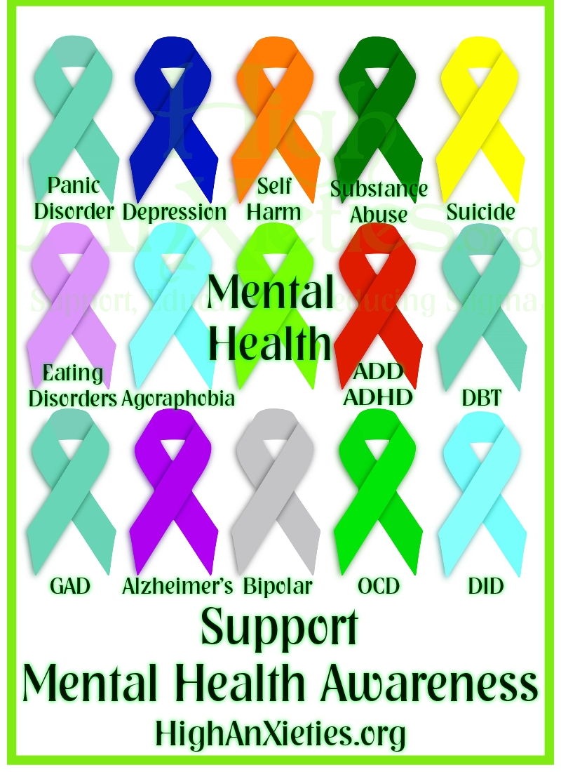

Mental Health and Addictions Services

The mental health of our school-aged children continues to emerge as a significant public issue. Advocating for supports for Mental Health Issues and Addictions, among our youth, are two of the main goals of the NLFSC. We often hear from parents who are searching for mental health and addictions resources for their children. NLFSC believes more Mental Health providers, who specialized in children and adolescents, and more Treatment Centers are needed in this province. NLFSC also continues to advocate for changes to legislation to ensure students receive the mental and emotional help they need.
NLFSC is committed to ensuring government follows through with the recommendations outlined in the education action plan which will result in:
- improved education for teachers and early childhood educators on mental health and wellness
- increased accessibility to health services for children and youth
- improved timelines of service delivery
- review of roles and responsibilities of specialist personnel
- specific learning outcomes for student mental health and addictions in most curriculum.

The NLFSC executive has met with officials from the Department of Education and the Department of Health and Community Services, numerous times, regarding the need for more Treatment Centres and supports, as well as a need for changes in legislation for secure treatment and withdrawal management for youth (court-ordered, mandatory treatment for youth suffering from addiction issues).

Administrative Allocation

The reduction in the allocation for School Administrator time in the 2013 and 2015 provincial budget resulted in less time for School Administrators to carry out their duties and responsibilities. Important initiatives such as Anti-bullying and Healthy Living programs are further compounding the stress placed upon our Administrators.
Mental health and addiction issues, and cuts to the teacher allocations - combined with cuts to the administrative allocation - have placed a huge administrative burden on Principals and Assistant Principals.
Many of the School Councils we speak with say “Our Principal has to teach more this year; therefore, it is extremely difficult to get a hold of him/her.”
NLFSC continues to lobby Government to reinstate the Administrative allocation to the level it was in 2012

Truancy

NLFSC feels school truancy (unexcused absences) poses a significant problem for the NL educational system and our society. Truant students suffer negative effects not only in their education, but also in their potential future financial earnings and their overall success in life. Despite the recognition of this problem efforts to curb truancy have proven largely ineffective. In fact, as of January 19, 5354 students in NL had accumulated 16 or more unexcused absences for the 2016-17 school year. This represents approx. 8% of our student population.
In the past, the issue of following up on students who were missing a significant amount of school time went to the Department of Child, Youth and Family Services and/or the RCMP.

There was also a Truancy Officer located at the Department of Education Early Learning designated to combat absenteeism. Unfortunately, neither of these interventions currently exist. Without these critical intervention’s truancy has become a growing concern in this province.

NLFSC is pleased to see the implementation of the Action Plan will result in better policies and procedures to address chronic absenteeism and school dropout, however NLFSC feels there is a need for more effective tracking of data related to truancy. Schools, parents, and communities cannot act to improve student attendance unless they understand which students are missing school. Effective monitoring will also help educators and communities identify students who are at-risk of becoming chronically absent.

Research suggests chronic truant students also benefit greatly from interventions and programs targeting attendance behaviors such as the PASS Program.
The PASS Program (A Positive Approach to Student Success) is a supportive program designed to assist at-risk students. The PASS program in NL yielded great success and many students graduated because of it. Many of these students, without this program, would have been lost in the system.
Eight teacher allocations were directed and used for the PASS Program; however, these allocations were eventually blended with the regular teacher allocations and the program gradually disappeared.
NLFSC would like to see the Pass Program in place and expanded to all areas of the Province with teacher allocations specially allocated for its implementation.

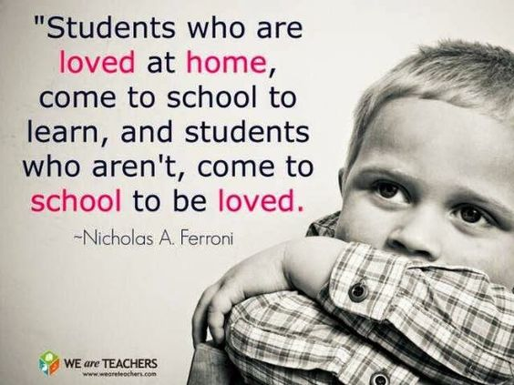

Teacher Allocations

NLFSC continues to lobby for increased teacher allocations - through the implementation of a Needs Based Formula.

NLFSC believes that a “needs based” formula as recommended and accepted by government in previous years, but has not been fully implemented, is critical to our schools and students. A Needs Based formula will address many deficiencies in the education system in the areas of Special Needs/ inclusion, improve classroom size at both the elementary and high school levels and provide full educational programming in our rural schools. This model would take the geography of our province into account and eliminate the need for a set pupil-teacher ratio.

Guidance allocations

NLFSC continues to lobby the Department of Education and government to change the allocation formula for Guidance Counselors to one per 250 students for Kindergarten to Level III.
This action stems from a resolution, passed at the NLFSC 2012-13 AGM and amended at the 2013-14 AGM, requesting more supports in Guidance.
Guidance resources and supports have to be increased to meet the demand in our schools. The role of the Guidance Counselor has changed dramatically over the past decade. Guidance counselors are now required to complete assessments, conduct peer, group, individual and grief counseling sessions, as well as ensure that students are receiving some level of career counseling and planning. Guidance Counselors also play a significant role in ensuring high school students are choosing the appropriate courses they need in order to graduate. As a result, Guidance Counselors assist directly in ensuring that high school graduation rates in the province are increasing, but they cannot be expected to implement new initiatives, in addition to the many other responsibilities they currently have to perform, without additional time and an increase in human resources.

Other recommendations put forth by NLFSC:

- Develop a plan to increase the number of Instructional Resource Teachers, Curriculum Support Teachers, Student Assistants, and counsellors in schools. The allocation formula for students with challenging needs should be truly ‘needs based assessment’ and generous in application.
- Give serious consideration to the inclusion of Social Workers and Occupational Therapists as professional employees within the schools in the near future.
- Increase the current Educational Psychologists allocation to 1:100
- Create a new allocation for Youth Mental Health and Addiction Counsellors, at a ratio of 1:500 students.
- Create a specific allocation for Curriculum Support Teachers
- Reduce Class size
Kindergarten – 18 students
Grades 1-3 – 20 students
Grades 4-6 – 23 students
Grades 7-12 – 25 students)
- Increase the teacher allocation for English Second Language to provide 0.50 teacher unit for every 15 ESL students.
- The Department of Education and Early Childhood Development review and revise how it calculates and reports graduation and pass rates so that these statistics more accurately reflect student achievement.
- The Department of Education and Early Childhood Development review and revise the language arts curriculum to ensure that it sets clear expectations to inform teaching and learning and contains reading materials that are responsive and meaningful to students.
- The Department of Education and Early Childhood Development increase the capacity of school libraries and teacher-librarians to support the curriculum by ensuring provision of sufficient library resources and personnel.

Education Partners

NLFSC maintains on-going liaison with other provincial stakeholders in education including the NL Teachers Association, Memorial University, School Milk Foundation, Kids Eat Smart Foundation, CONA, NL Association of Social Workers, Association of Psychology, Retired Teachers Association, Association for Community Living, Canadian Mental Health, Learning Disabilities, Canadian Cancer Association, Community Sector Council, Community Food Sharing Association, Sports NL, School Lunch Association, NL Division of the Canadian Mental Health Association and the Alliance for the control of Tobacco, NL. These are just a FEW of the agencies who contact and request meetings with NLFSC. Many of these agencies also use NLFSC’s resolutions, views and numerous media quotes to strengthen and support their own surveys, reports and requests for more resources.

NLFSC continues to be a strong advocate for students and schools, and is increasingly being recognized as a crucial component of a strong and vital education system. We are committed to promoting the importance of a quality education, and continue to advocate for education resources, both human and physical, for our schools.

