The Cuffer

A Newspaper for School Councils in Newfoundland and Labrador

May/June 2019

Message from the NLFSC President

It is hard to believe we are at the end of another school year. On behalf of the NLFSC executive many thanks to you, our membership, for the dedication and effort you have given to students and schools across this province.

We sincerely appreciate each volunteer that serves on our School Councils and the impact

they have on the education system both locally and provincially.

The NLFSC executive would like to assure our membership that NLFSC’s educational advocacy will continue to push for improvements in the areas of inclusive education, violence in schools, mental health and addictions, truancy, literacy and mathematics, school council training, curriculum support in the classroom, and guidance/administration allocations.

We were extremely disappointed that our request for an increase to the administration allocation was not included in the recent provincial budget. The principal is responsible for nearly every ongoing process in any given school, as well as the quality of teaching and learning. Therefore there MUST be a provision for adequate time to help Administrators perform well in their role, and fulfil their responsibilities.

NLFSC will continue to lobby government to reinstate the Administrative allocation to the level it was in 2012. This will be one of the topics on our agenda when we meet with the Hon. Brian Warr – the new Minister of Education and Early Childhood Development - in the next few months.

Over the past year, the executive has worked hard to strengthen relationships and better communicate with the federation’s primary audiences - members, government, our two school boards, and the NLTA. We have been successful in broadening our reach, in communicating our key messages and taking a coordinated approach to significant challenges facing education in our province.

Many thanks to all of you for your continued commitment and dedication to the students across NL and to NLFSC.

It has truly been an honour to serve as your President for the 2018-19 school year.
On behalf of the other members of the executive David Hillier, Lori Barry, Ruby Hoskins and Denise Pike, best wishes for a safe and relaxing summer,
See you in September!

Sincerely,
Don

Don.Coombs@easternhealth.ca

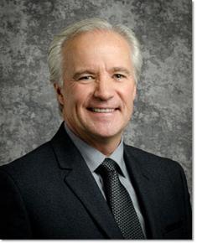

New Minister

Congratulations to Hon. Brian Warr, on his recent appointment as Minister of Education and Early Childhood Development
The NLFSC executive looks forward to meeting, and working with Minister Warr in what is truly a critical portfolio.

Atlantic Caucus Meeting

NLFSC will host Atlantic Caucus Meetings of the Home and School/School Councils Associations, in St. John's on November 16, 2019

Representatives from the Home & School Federations in Nova Scotia, New Brunswick, Prince Edward Island and the Federation of School Councils in Newfoundland Labrador will meet to discuss priority issues in education.

There is tremendous benefit in having all four Atlantic Provinces meet on a regular basis to talk about the importance of education advocacy. Members of the NLFSC Executive look forward to discussing legislative changes, best practices and various topics of mutual concern with the other provincial associations.

Each provincial association will also present a written report of current provincial education initiatives, on-going concerns and priorities.

The Atlantic Caucus of Home and School/School Council Federations aims to encourage discussion on common issues in public education in Atlantic Canada and bring added value to provincial associations.

2019-20 School Calender

Holiday Schedule

September 3 - Administration Day
September 4 - School Reopens/Students
October 14 - Thanksgiving Day
November 8 - Mid Fall Break
November 11 - Remembrance Day
December 20 - Last Day of School - Christmas
January 6 - School Reopens
February 17 - Mid Winter Break
March 16 - St. Patrick's Day
April 9 - Last Day of School - Easter
April 20 - School Reopens
May 18 - Victoria Day
June 25 - Last Day for Students
June 26 - Administration Day

Call for Nominations for the NLFSC Board of Directors

Take an active role in the governance of your Federation!
Why not consider running for a position on the Board of Directors. We are seeking candidates for the positions of Vice-President and Secretary

Vice-President (Term of Office: 2019-2021)

- Review documents (e.g. press releases, briefs) and advise as needed
- Serve in such capacities as may be designated by the President, the Biennial Meeting, or the Board of Directors.
- A Vice-President shall preside at meetings in the absence of the President, and address media.
- Represent the Federation at meetings, conferences, etc.
- Participate in executive meetings

Secretary (term of Office 2019-2021)

- Keep a record of the proceedings and attendance of all meetings of the Federation
- Reviews and edits documents (e.g. media releases, briefs, reports) and advises as needed
- Represents the Federation at meetings, conferences, etc.
- Participates in Executive meeting

If you have any questions, please email: nlfsci@gmail.com

The Federation is a provincial organization. We welcome candidates from anywhere in the province of Newfoundland Labrador. All you absolutely need is access to a telephone and e-mail.
It’s your organization – Make it what you want it to be.

Self-nominations are welcome!

Nomination Form attached.

Nominations MUST be submitted to NLFSC by September 10, 2019

Prime Minister's Award

Congratulations to Nancy Ryan, Grade three teacher at St. Matthew’s School in St. John’s, on winning the Prime Minister’s Award for Teaching Excellence in STEM Certificate of Achievement.

The Prime Minister's Awards for Teaching
Excellence honour outstanding and innovative elementary and secondary school teachers in all disciplines who instill in their students a love of learning and who utilize information and
communication technologies to better equip their students with the knowledge and skills needed to excel in a 21st century society and economy.

The award bestowed to Ms. Ryan honours outstanding science, technology, engineering and math (STEM) teachers who keep students engaged in these fields.

The award appropriately reflects the endless hours Ms. Ryan has spent ensuring that each individual student obtains every opportunity to fully realize his or her talents and gifts.

Her enthusiasm, insight, and devotion to connect learning to the “real world” is inspiring. Her innovative teaching style, to challenge students to search for deeper answers, is truly admirable and has earned her this very deserving recognition.

On behalf of NLFSC executive, thank you for your commitment to students and learning - our sincerest congratulations on this great achievement.
The Prime Minister’s Awards carry a cash prize, letter and a certificate signed by the Prime Minister.

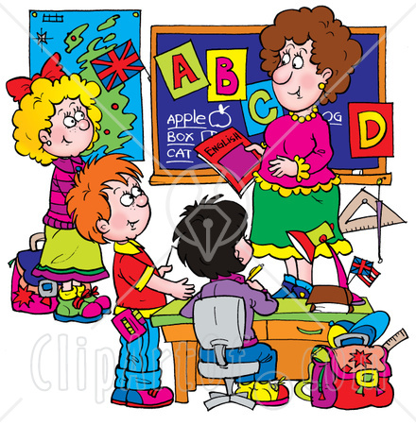
Anyone who does anything to help a child in his life is a hero to me.” – Fred Rogers (Mister Rogers)

2018-19 School Council Person of the Year Award

NLFSC is currently accepting nominations for the 2018-19, School Council Person of the Year Award.

Purpose
The purpose of the Award is to publicly recognize significant and outstanding achievements of School Council Members.

Candidates
Candidates for the award may be any school council member (i.e. parents, teachers, students, community reps, principals).
Candidates who contribute by actions and efforts to the development of a positive learning environment may be nominated by their colleagues, students, or parents.

Criteria
• Performance of volunteer duties at a high level at all times.
• A significant school and/or system-related
achievement.

• A specific innovation or achievement of
significant value or importance to the school community, or a unique circumstance considered worthy of recognition by the NLFSC Board.
• A member of a School Council in good standing with the NLFSC.

Nomination Procedure
Nominations will be submitted on the Award nomination form by: Individual School Council members, Students, Parents, or School Council as a whole.
Nominations must include:
- The name of the candidate(s) and School Council location.
- Names of at least two nominators and their positions; or the School Council chair on behalf of the entire School Council.
- Signature of the administrator or School Council Chair along with a short rationale for the nomination.
The provision of supporting documentation (letters of support, etc.) is important because it provides background information for members of the selection committee.
Nomination Form attached

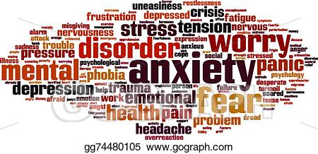

Children and young adults are showing up in Canadian hospitals to get help with mental health-related issues far more often than in the past, bucking a trend that sees overall youth hospital visits on the decline.

According to new data from the Canadian Institute for Health Information (CIHI), there was a 65 per cent increase in mental health-related hospitalizations of Canadians between the ages of five and 24 from 2006-07 to 2017-18, as well as a 75 per cent increase in mental health-related emergency room visits. Hospitalizations for other conditions fell by 24 per cent in that age group over the same time period.
Girls and young women were responsible for slightly more of the ER visits and hospitalizations than boys and young men. Hospitalization rates were highest in the Northwest Territories and Nunavut, and lowest in Nova Scotia and Manitoba.

The increases occurred even though the prevalence of young Canadians being diagnosed

with mental health-related disorders over the 12-year period was relatively unchanged.
Additionally, CIHI found that 9.3 per cent of young Canadians, or about one in 11, were given medication for a mood or antipsychotic disorder in 2017-18.

The Cuffer is a benefit of membership in the Newfoundland and Labrador Federation of School Councils.
The views expressed or implied in this publication are not necessarily official positions of the Federation.
The mention of any program, organization, resource, product, person, place, or school does not constitute an endorsement by the NLFSC.

Editor: Denise Pike, Proof Reader: Lori Barry

NLFSC Contact Information
P.O Box 23140
St. John’s NL
A1B 4J9

Email: nlfsci@gmail.com
www.facebook.com/nlfederationofschoolcouncils www.schoolcouncils.nl.ca

