The Cuffer

A Newspaper for School Councils in Newfoundland and Labrador
Fall 2019

Message from the President

On behalf of the NLFSC executive, welcome back to a new school year. I hope you had a safe and relaxing summer holiday.
NLFSC's mission is to continue to be a voice for parents and school councils on issues affecting their children and schools. Together we have the strength to influence policy and ensure safe and caring learning environments for our children.

At this time many school councils are setting the agenda for their first meeting of the year.
School councils are mandated organizations that facilitate parental participation in our schools.
School councils are an excellent way for you to get involved in your child’s education. - and is an important forum for involving parents/family and community in matters that affect the education of students.

If this is your first year on a council be sure to locate a copy of the School Council Handbook, or download it at:
www.ed.gov.nl.ca/edu/publications/k12/Handbook2ndedition.pdf
This document is an invaluable resource in assisting school council members to understand their roles and responsibilities.
A School Councils effectiveness often depends on how it develops and utilizes the capabilities of its members. A good School Council will have a mix of members reflecting the school community.
One of the most important functions of School Council is to advise on the quality of the teaching and learning in the school.

School Councils are also responsible for advising the board on matters of concern to the school and to the school community.
School Councils promote transparency as council actions and decisions are communicated to the school community through their meeting minutes. Minutes should be posted on the school’s website.

I believe our students are among the best in the world and that is due, in part, to the active involvement of parents and community members. School Councils and parents can make a meaningful difference in the lives of students - and we applaud your contributions. By connecting students, schools and your community, school councils help nurture and inspire our students to achieve their full potential.

I am very proud of our students and of our dedicated teachers and school staff.
We must always remember there are many great things taking place in our schools every day. Together we will continue to promote the achievements of our students and continue an ongoing dialogue about the value, purpose, and future of public education in this province.

On behalf of the executive and our Executive Director, I want to wish you a safe and successful school year.
Please do not hesitate to contact us with questions, advice or request support at nlfsci@gmail.com or by calling the NLFSC office at (709) 764-8993.

Sincerely,
Don

Email:Don.Coombs@easternhealth.ca

New NLFSC Vice-President

Congratulations to Craig Tavenor of Mount Pearl who was recently acclaimed
Vice-President of NLFSC. Craig took an interest in education and started volunteering in school when his children, now 17 and 20 were young.
He firmly believes there is a positive and convincing relationship between family involvement and student success when families are involved in their child's learning, their children do better in school.
Craig has been a member of the O'Donel High School Councils for the past 3 years serving as chairperson for the past 2 years.

“Since becoming involved with my school council I have seen some of the challenges our students and educators face. It is an exciting time in our province and having a world class education system is critical to their success. Our

youth and our society need a strong education system to help them achieve their full potential.”

Craig served as NLFSC Vice-President for a few months during 2018 - completing a term left vacant when the previous Vice-President resigned.
He believes school councils have great potential and can provide parents with a voice on education concerns and looks forward to furthering the NLFSC mandate for excellence in education for all children.
Email:cttavsmail@gmail.com

NLFSC Secretary

Lori Barry was recently acclaimed Secretary of NLFSC. Lori has been a teacher for the past 22 years and is currently teaching at Exploits Valley Intermediate School in Grand Falls Windsor. She has served on various school councils in that community for the past 8 years. Lori has served one term as Secretary with the NLFSC and we are excited to have her back for another. Lori has years of experience volunteering with youth organizations such as Allied Youth and The Salvation Army Youth Dept. as well as experience with committees and organizations within the education field such as the NLTA and special interest councils and action committees with the Dept. of Education. Lori has two sons one in grade 10 and one in his first year of University.

“After attending my first NLFSC AGM six years ago I realized the very valuable resource the federation is to schools and parents. Our school councils can be, when implemented properly, an effective voice for parents and
teachers. As a teacher I experience first-hand the challenges that are facing our children and
educators in our school system. The NLFSC offers our parents as well as our teachers an avenue to voice concern and become more informed. As a parent, I appreciate the efforts of the federation to enhance the quality of our children's education.
If we are not passionate in our pursuit for excellence in our children’s education then we cannot expect the powers that be to be passionate about administering it.
I am honoured to accept a role in an organization that will help me to be a part of moving the education system forward in our province to provide our children with the best possible opportunities for their future.”

Other members of the NLFSC Executive:
Don Coombs (President)
Email:Don.Coombs@easternhealth.ca
David Hillier (Vice President)
Email:davidhillier@gmail.com
Ruby Hoskins (Past President)
Email:rubyhoskins63@yahoo.ca
Asley McCarthy ( Treasurer) - Asley manages and oversee our finances. Without Ashley's
volunteer support and guidance the extent of what we have accomplished would not be possible.

Canada’s Outstanding Principal

Do you have an outstanding Principal at your
school? If so, show your appreciation to your principal for all their hard work by nominating them for Canada’s Outstanding Principal Award.
This award recognizes the unique and crucial
contribution of Principals in publicly funded
schools.
Visit www.thelearningpartnership.ca for more
Information

Media Interviews

Over the past month President Coombs has been quite busy representing the goals of the NLFSC and advocating for our students.
Don was interviewed by the media on a number of education issues including bullying
parental involvement in education, back to school issues, teacher hiring, mental health and addictions among youth and the elimination of final exams for junior high students.

Meetings

NDP MHA Jim Dinn (education critic) to
discuss education concerns and the need for an increase to the NLFSC Operating Grant
Brian Warr, Minister of Education and Early Childhood Development
Topics and Concerns included:
NLFSC Operational Funding, Teacher Hiring
Process, Reporting /Exams, Financial
Literacy, Teaching and Learning
Assistants, Education Action Plan, and
the Auditor General's Report

Meeting with Eldred Barnes, Associate Deputy Minister of Education and Early Childhood Development, for an update/ overview on the Education Action Plan

Meeting scheduled for November 7 with Tony Stack, CEO of English School District. We have requested a meeting with the NLTA

NLFSC also attended a forum on Vaping and participated in several provincial committees relating to education and the health and safety of students

Membership Renewal

This year marks the 40th year the
Newfoundland and Labrador Federation of School Councils (NLFSC) has been representing local school councils, PTAs, and home and school associations. There are many changes and challenges taking place in the school system and NLFSC is busy advocating on your behalf.
Your continued membership will help support our mission in striving for excellence in
Education, for all children in Newfoundland and Labrador, and to represent your school council as part of the collective voice for school councils and for all parents/guardians.
(Membership application attached)

Atlantic Caucus Meeting of School Council Federations/Home and School Associations

Don Coombs, President of the Newfoundland and Labrador Federation of School Councils, (NLFSC) will chair the Atlantic Caucus Meeting of the Home and School/School Councils Associations in St. John's on November 16th.

Representatives from the Home & School Federations in Nova Scotia, New Brunswick, Prince Edward Island and the Federation of School Councils in Newfoundland Labrador will meet to discuss priority issues in education.

Each provincial representative will also present a written report of current provincial education initiatives, on-going concerns and priorities.

The Atlantic Caucus of Home and School/School Council Federations aims to encourage discussion on common issues in public education in Atlantic Canada and bring added value to provincial associations.

School Holiday Calendar 2019-20

- October 14 - Thanksgiving Day
- November 8 - Mid Fall Break
- November 11 - Remembrance Day
- December 20 - Last Day Prior to Christmas
- January 6 - School Reopens
- February 17 - Mid Winter Break
- March 16 - St. Patrick's Day
- April 9 - Last Day of School - Easter
- April 20 - School Reopens
- May 18 - Victoria Day
- June 25 - Last Day for Students
- June 26 - Administration Day
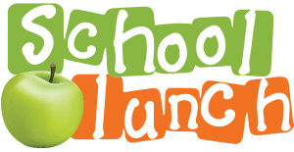

Submitted by the School Lunch Program

The School Lunch Association is a registered charity whose mission is to operate a non-stigmatizing program that provides a hot, nutritious lunch for school children, regardless of a families’ financial situation. The program serves over 6,300 meals each day, in 36 schools across Newfoundland.

In Newfoundland and Labrador 1 in 5 children grow up in a low-income family. Many of these low-income families experience a high degree of food insecurity. The School Lunch Association provides lunch for any child, regardless of their family’s ability to pay.

The School Lunch Association provides 2-3 servings of fruit and vegetables every day. Last year we served more than 30,000 lbs of fruit and vegetables in our lunches!

Approximately 14,000 students have access to the School Lunch program each day. This represents 50% of the primary and elementary students on the Avalon or 30% of all primary and elementary students in the Province.

Our program is expanding rapidly. This year, with the addition of 2 new schools, we will average 6,300 meals a day. These additions will substantially increase the children who have access to the School Lunch program.

We have received $125,000 from the Provincial Government this year. This is the only Provincial funding we receive and translates into a mere 13 cents per meal. Our 2019 budget is approximately $3.1 million. Schools are not required to fundraise for the program, nor are they asked to supply food, volunteers, or purchase equipment for us to operate.
The Association does not receive any funding from the Federal Government.

How to Register
To take part, parents must first register their children. Registration takes place each year and will be available starting in August.

Parents can register their children at www.schoollunch.ca. Payments can
be made by Visa or Mastercard online.
Alternatively, parents can print and complete the registration form (located on website), then submit the form, as well as your payment at your school, or at the School Lunch office.

The registration cost each year is $10 for one child, $15 for two children, or $20 for three or more children.
Parents are encouraged to order online
at www.schoollunch.ca.

Online ordering
Each month our online ordering opens
for the following month service. For
example, for October’s lunches, ordering
takes place a week in September. Online
orders are payable by Visa or Mastercard.
A username and password is required to
access the online ordering system. You
would have been asked to set one up, if
you completed your registration online. If
you submitted a paper registration form,
you will need to call our office at
754-5323 to have a username and
password set up.

Paper Menu Ordering

Each month we send out a paper menu
and envelope to schools for the following
month service. Paper menus and

envelopes are distributed to students who
are registered for paper ordering.
Parents choose lunches they would like,
then return the completed envelopes
to their school. Envelopes can also be
dropped off at our main office.

Our goal is to expand the School Lunch program throughout Newfoundland & Labrador. We recently celebrated our grand opening at Clarenville Middle School.

To arrange a time to discuss the concept of expanding the School Lunch Program to
your school, please contact Ken Hopkins,
Executive Director of the School Lunch Association @ 709-754-5323 (Ext: 223)
Email: khopkins@schoollunch.ca

Provincial Public Education and Awareness Youth Vaping Campaign

Between October 15-25, 2019 teachers across the Province will be giving a presentation to Grade 7-12 students entitled “Vaping and E-cigarettes – Get the Facts”. This presentation has been developed by the NL Alliance for the Control of Tobacco in partnership with the English School District.
To support teachers and professionals, ACT will also be hosting a youth and vaping webinar, “The New Look of Nicotine Addiction – Get the Facts” on Wednesday October 23, 2019 and Thursday October 31, 2019. This webinar is targeted towards those working with youth in the areas of public health, mental health, education and community.
To register for this webinar please contact melissamoore@actnf.com.

Need Help Quitting?

The Newfoundland and Labrador Smokers' HelpLine is here for you.
Visit them at Smokers' HelpLine or call 1-800-363-5864 to talk to a quit-coach today!

Tobacco Report

In 2017, almost 5 million people, representing 15.1% of the population of Canada 15 years and older, continued to smoke. Based on data contained in the 2017 Canadian Tobacco, Alcohol and Drugs Survey (CTADS), the prevalence of smoking in Newfoundland and Labrador currently stands at 20%.
Currently, in Newfoundland and Labrador:
- 15-19 years: Current smokers – 10%
- 20-24 years: Current smokers – 24%
- 25+ years: Current smokers – 20.4%
- 45+ years: Current smokers – 19.6%
- 13% to 27% of women use tobacco during pregnancy, and women under 25 are more
likely to report that they smoke regularly while pregnant.
In addition, according to CTADS, 21% of males aged 15+ in Newfoundland and Labrador are current smokers while 18.5% of females aged 15+ are current smokers.

Smoking doesn't just cost the smoker – it costs employers too.
According to “Up In Smoke” by the Conference Board of Canada, smoking costs both the smoker and their employers a lot of money each year. A pack a day smoker can spend up to $3500 a year on their addiction while employers can pay up to $4000 per smoking employee each year.

Student Appeals

The Newfoundland and Labrador English School Board recognizes that students and
parents/guardians may sometimes disagree with decisions of the Board.

Many student concerns can best be resolved through informal means at the school level, or by involving district staff. However, students
and parents or caregivers have the right to formally appeal in writing to the Board a decision which significantly impacts them, in accordance with Section 22 of the Schools Act, 1997.

Before beginning an appeal at the District level, parents/guardians and/or students are strongly encouraged to try to resolve the issue at the school level.

The determination of whether a decision or a failure to make a decision significantly impacts upon a student's education, health or safety shall be made on a case-by-case basis.
More information can be found on the English School District website.
Student Appeals Policy, Student Appeals FAQs
Student Appeals Steps, Student Appeals Form

International Walk to School Month

October is International Walk to School Month.
It gives children, parents, school teachers and
community leaders an opportunity to be part of a global event as they celebrate the many benefits of walking. Walkers from around the world walk to school together for various reasons — all hoping to create communities that are safe places to walk.
To learn more about this event and to register
and receive stickers or promotional posters
please visit http://www.iwalktoschool.org/

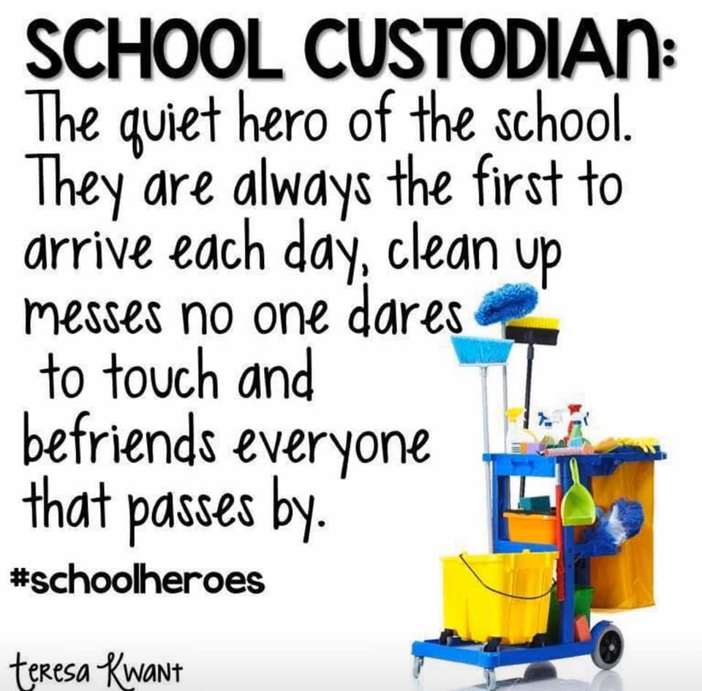

The Cuffer is a benefit of membership in the Newfoundland and Labrador Federation of School Councils.
Annual membership dues are based on school enrollment.

The views expressed or implied in this
publication are not necessarily official positions of the Federation.
The mention of any program, organization,
resource, product, person, place, or school does not constitute an endorsement by NLFSC.

Editor: Denise Pike
Proof Reader: Lori Barry

NLFSC Contact Information

P.O Box 23140
St. John’s NL
A1B 4J9
Tel: (709) 764-8993

