The Cuffer

A Newspaper for School Councils in Newfoundland and Labrador

May/June 2021

Message from the NLFSC President

As we approach the final days to end this school year, we wanted to extend our appreciation to, our membership, for the dedication and effort you have given to students and schools across this province.
We also want to thank parents and guardians for supporting schools and education during this past year. We know online learning wasn’t

always ideal and presented many challenges for parents, but you did your best to ensure your children continued to learn from the comfort and safety of your homes.
We do hope online instruction has helped to instill the value of learning in and out of the classroom setting. Learning is a lifelong skill that can take place in any setting, as we have seen demonstrated over the past year.
On another note, NLFSC is pleased about some of commitments to education announced in the recent provincial budget.
We are relieved there will be no cuts to the school administrator and guidance counsellor positions for the upcoming school year. I expect this commitment is a temporary one, however we will continue to advocate for these positions. It is imperative that the school administrator allocation be reinstated to the level it was in

2012. We desperately need an increase to the Guidance Counsellor allocation as well.

The recent announcement to integrate the English School District into the Department of Education will mark a significant change in the governance of education in this NL. We are pleased to be involved in consultations regarding these changes and will update our membership as soon as we are able
NLFSC is a collaborative organization and we recognize the importance of building strong relationships and communicating key messages to our members. Thank you for supporting our advocacy over the 2020-21 school - and for your continued commitment and dedication to the students of NL. We sincerely appreciate each volunteer that serves on our School Councils and the impact you have on the education system both locally and provincially.

On behalf of the other members of the NLFSC Executive, best wishes for a wonderful, safe summer holiday.
Sincerely,
Don

Don.Coombs@easternhealth.ca

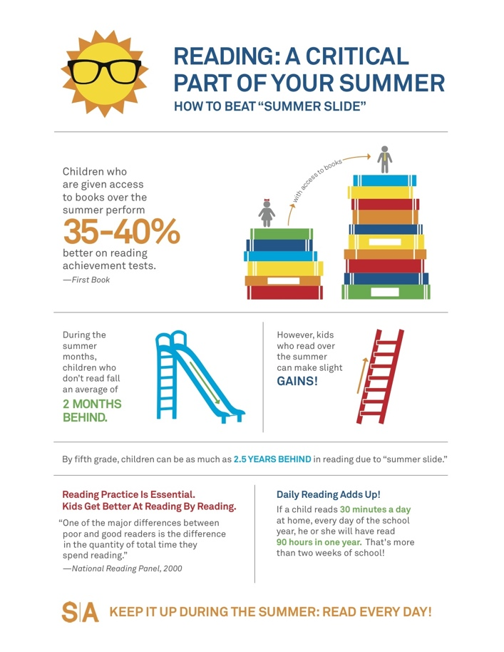

As we move into the summer, it is extremely important that students continue their growth in reading and literacy. Reading 20 minutes a day will allow students to continue that growth. Reading on grade level is one of the strongest indicators of success for students.
For many students, summer can provide time away from school to leisurely read for fun and interest. There is plenty of research to support the benefits of summer reading, especially when it comes to preventing a decline in reading skills also known as the “Summer Slide”.

Evidence suggests the summer slide is a real problem and continuing purposeful reading habits over the summer can help prevent learning loss.
Sustaining good reading habits over the
summer positions students to succeed in the coming school year.
There is a lot of research that says “regardless of ethnicity, socioeconomic level, or previous achievement, children who read four or more books over the summer fare better on reading comprehension tests in the fall than their peers who read one or no books over the summer.”

Summer can provide the opportunity for
children to take ownership of the reading process and gives agency to students to read on their own terms. The more casual nature of summer reading lets students blossom into their identity as readers.

Tips to make reading enjoyable for your children this summer:

- Read aloud together with your child every day. Make it fun by reading outdoors on the front steps, patio, at the beach or park. Also, let your children read to you. For younger children, point

out the relationship between words and sounds.

- Set a good example!
Parents must be willing to model behavior for their children. Keep lots of reading material around the house. Turn off the TV and have each person read his or her book, including mom and dad.

- Read the same book your child is reading and discuss it. This is the way to develop habits of the mind and build capacity for thought and insight. Let kids choose what they want to read, and don't turn your nose up at popular

- Buy books on tape, especially for a child with a learning disability. Listen to them in the car, or turn off the TV and have the family listen to them together.

- If public safety measures allow, take your children to the library regularly. Most libraries sponsor summer reading clubs with easy-to-reach goals for preschool and school-age children. Check the library calendar for special summer reading activities and events.

- Subscribe, in your child's name, to magazines like Sports Illustrated for Kids, Highlights for Children, or National Geographic World.
Encourage older children to read the newspaper and current events magazines, to keep up the reading habit over the summer and develop vocabulary. Ask them what they think about what they've read, and listen to what they say.

- Ease disappointment over summer separation from a favorite school friend by encouraging them to become pen pals. Provide children with postcards or envelopes that are already addressed and stamped. If both children have access to the Internet, email is another option.

- Make trips a way to encourage reading by reading aloud traffic signs, billboards, notices. Show your children how to read a map, and once you are on the road, let them take turns being the navigator.

- Encourage children to keep a summer scrapbook. Tape in souvenirs of your family's summer activities picture postcards, ticket stubs, photos. Have your children write the captions and read them and read them aloud as you look at the book together.

National Indigenous Peoples Day
Sunday, June 21, 2015

In Canada June 21 is known as National Indigenous Peoples Day. This is a day for all Canadians to recognize and celebrate the unique
heritage, diverse cultures, and outstanding contributions of First Nations, Inuit, and Metis’ people.
The Canadian Constitution recognizes these three groups as Aboriginal peoples, also known as Indigenous people.
Although these groups share many similarities, they each have their own distinct heritage, language, cultural practises and spiritual beliefs. In cooperation with Indigenous organizations, the Government of Canada chose June 21, the summer solstice for National Indigenous Peoples Day.

NLFSC joins with millions of Canadians in
expressing great sorrow at the discovery of the bodies of 215 children at the former Kamloops Indian Residential School in B.C.
The children, whose deaths are thought to be undocumented, include some as young as 3 years old.
Residential schools were funded by the
Canadian government and run by churches from the 1870s, with the last school shut in 1996,
according to the Truth and Reconciliation Commission of Canada. There were more than 130 of the institutions across the country.
At least 150,000 children belonging to First
Nation, Inuit and Metis groups attended the schools, which sought to suppress their cultural and religious identities and force them to
assimilate into white Christian society.
The discovery of the unmarked graves illustrates the damage Canada’s residential school system continues to precipitate, decades after being disbanded. The pain and intergenerational trauma of this shameful, dark chapter in the history of Canada has had long lasting effects on the children, grandchildren, great-grandchildren, and Indigenous communities of today.
We grieve with you.

Provincial Budget Highlights Impacting Education

- $22 million to maintain the significant additional teaching resources hired through the Education Action Plan since 2018.
- More than $13 million to maintain key COVID-19 staffing and supports in K-12 education for the current school year, and to maintain increased administrator and guidance counsellor positions for the upcoming school year.
- $2 million in professional learning for teachers, school administrators, and guidance counsellors who will be implementing new programs and services arising from the Education Action Plan.
- $357,000 to hire additional English-as-a-Second Language teachers to address the educational needs of newcomers to our province.
- $12 million to enhance and increase accessibility to adult literacy programs and services, as well as improve the employability of persons with literacy challenges.

- $18.8 million has been allocated to complete construction on new schools in Bay Roberts, Gander, Paradise, and St. Alban’s.
- $19.5 million has been allocated for alterations and improvements for schools throughout Newfoundland and Labrador.
- $1 million in funding for ventilation improvements at existing schools.
Newfoundland and Labrador English School District
- With the goal of making better use of our considerable investment in education and to ensure that investments target the classroom, not administration, we will be taking the appropriate steps to integrate the Newfoundland and Labrador English School District into the Department of Education
- 25 million to improve connectivity through cellular and broadband service

Atlantic Caucus Meeting

On May 31st, NLFSC, along with representatives from Home and School/School Councils Associations from Nova Scotia, New Brunswick, and Prince Edward Island met, via Zoom, to discuss education. The meeting focussed on the impact of instruction and learning amid the pandemic, however several other areas of mutual concern were identified including the need for Automatic External defibrillators (AED) in schools.

There is tremendous benefit in having all four Atlantic Provinces meet on a regular basis to talk about the importance of education advocacy. Members of the NLFSC Executive look forward to discussing legislative changes, best practices and various topics of mutual concern with the other provincial associations.
The Atlantic Caucus of Home and School/School Council Federations aims to encourage discussion on common issues in public education in Atlantic Canada and bring added value to provincial associations.

2021-22 School Calendar

Holiday Schedule

September 7 - Administration Day
September 8 - School Reopens/Students
October 11- Thanksgiving Day
November 11 - Remembrance Day
December 22 - Last Day of School - Christmas
January 4-School Reopens
April 14 - Last Day of School - Easter
April 25 - School Reopens
May 23 - Victoria Day
June 23 - Last Day for Students
June 24 - Administration Day

NLHC Scholarship Program

This year Newfoundland and Labrador Housing Corporation (NLHC) will award a total of twelve scholarships valued at $1000 each. This will include six Youth Scholarships (two in each of the following regions: Avalon/East, Central, Western/Labrador), and six Adult
Scholarships (two in each of the three regions). The deadline for applications for the Youth and Adult Scholarship programs is September 30, 2021.

Youth Program Eligibility
To be eligible for NLHC’s Youth Scholarship Program, your legal guardian(s) must be either:
Living in a NLHC rental unit and their
signature appears on the rental lease;
Living in a rental unit being subsidized by NLHC under the Rent Supplement Program;
Receiving a mortgage subsidy from NLHC and their signature appears on the mortgage
document; or Living in Co-op housing or
Partner-Managed housing which is being
subsidized by NLHC and their signature
appears on the occupancy agreement or lease.
You must also meet the following eligibility requirements:
Graduating from the Newfoundland and

Labrador high school system in the current school year (June 2021);
Attending a program of study at any approved post-secondary education or career training
institution on a full-time basis in the fall of 2021.

NLHC’s 2021 Youth Scholarships will be based on the student’s Academic or Honours
graduation average as set by the Department of Education and Early Childhood Development.

Adult Program Eligibility
Six scholarships, two in each region, are
available to adult tenants. An adult tenant can be the leaseholder (the person in the household who signed the lease, mortgage, or occupancy agreement) or an occupant (a person in the household who isn’t the leaseholder and doesn’t fall in the Youth Program category).

To be eligible for NLHC’s Adult Scholarship Program, you must be either:
Living in a NLHC rental unit;
Living in a rental unit subsidized by NLHC under the Rent Supplement Program;
Receiving a mortgage subsidy from NLHC; or
Living in Co-op housing or Partner-Managed Housing which is being subsidized by NLHC.

You must also meet the following eligibility requirements:
attending a program of study at any approved post-secondary education or career training
institution in the fall of 2021. You must be
enrolled in a full-time program and be in attendance through to December 31, 2021. This attendance must be confirmed.
(Important: If you are graduating from the Newfoundland and Labrador high school system in the current school year and

planning to attend a post-secondary
education or career training institution in the Fall of 2021, you must apply for the Youth Scholarship.)

Adult scholarships will be awarded based on reviews that assess need, initiative, and
community involvement.
Adult scholarships are not limited to first-year students.
If an applicant won a scholarship under the Youth Program in a previous year, they can
reapply under the Adult Program. Adult applicants are only eligible to win Adult
Scholarships twice.
If you are renting or receiving a mortgage
subsidy from NLHC and applying as the
leaseholder, your account must be in good standing at the time your application is
reviewed for eligibility.
Note:
Information on the application form must be valid at the time the application is reviewed for eligibility.

Should you change your post-secondary
institution after you submit your application, you are responsible to contact NLHC at
724-3055 to have your application updated.

Graduates from Adult Basic Education (ABE) are eligible to apply.

Tenants living in NLHC’s Market-Rental
housing are not eligible to apply.

Applications
Scholarship applications are available from NLHC’s regional offices, or by contacting:
Telephone: (709) 724-3055

Applications can be mailed or emailed to:
2021 Youth Application
2021 Adult Application
Corporate Communications
Attention: Scholarships

Newfoundland Labrador Housing
P.O. Box 220
St. John’s, NL A1C 5J2

E-mail: scholars@nlhc.nl.ca
Deadline:
Youth and Adult applications must be postmarked no later than September 30, 2021.

Dancing Backwards Society - a non-profit
organization has developed a school program promoting gender equality, gender parity in governance and leadership and good
citizenship.

This free, interactive, bilingual (French and English) online course for teachers for grades 5 and up, can be found at www.dancingbackwards.ca. The program is
fully downloadable, with eight lesson plans, videos, activities and a final project outline where students discover, document and
celebrate women political role models.
Dancing Backwards satisfies various Ministry
curriculum criteria across the country in Social Studies, English, History, Government and Arts Education.

For more information, contact:
Camille Ancessi
Executive Assistant, Dancing Backward Society
604-788-8065
www.dancingbackwards.ca

The Cuffer is a benefit of membership in the Newfoundland and Labrador Federation of School Councils.
The views expressed or implied in this publication are not necessarily official positions of the Federation.
The mention of any program, organization, resource, product, person, place, or school does not constitute an endorsement by the NLFSC.

Editor: Denise Pike, Proof Reader: Lori Barry

NLFSC Contact Information
P.O Box 23140
St. John’s NL
A1B 4J9

Email: nlfsci@gmail.com

