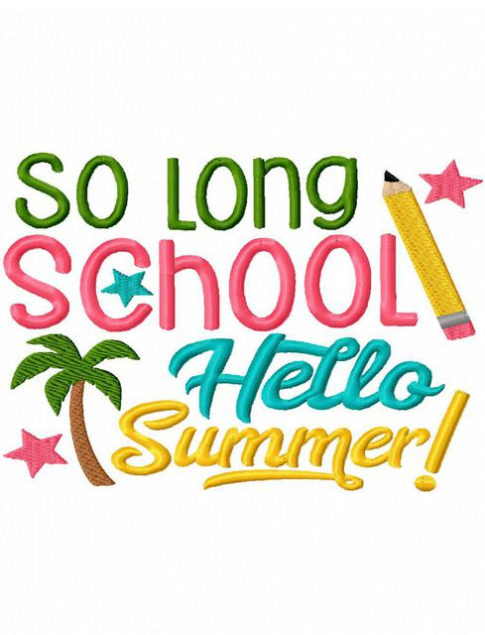
The Educator
A newspaper for School Councils in Newfoundland and Labrador

June 2022

Message from the President

As we approach the final few weeks of the
2021-22 school year, I would like to take this opportunity to say how truly honored I am to represent such a dedicated group of volunteers across this province who are diligently working to make student success and achievement a priority.
This has been a very challenging school year and we know our councils, parents, school staff, and students are looking forward to a much-needed break.
Thank you for your patience and support over this past year. Many of you called and emailed the NLFSC office or contacted me personally, and I felt your frustration and shared your anxiety on the many issues surrounding the pandemic and its impact on learning and school life. Your concerns were always included in our discussions with Minister Osbourne and the English School District. I am sure you all agree the commitment and patience demonstrated by our teachers, administrators, and ALL other school staff has been second to none over the past 10 months. Their dedication to teaching and devotion to our students has been outstanding. I was, and continue to be, very touched by the determination of our teachers to ensure learning continued regardless of any interruptions caused by the spread of the virus. The activities and events I saw (posted to social media and twitter) taking place in schools throughout the province were extremely uplifting. I witnessed hundreds of students participating and enjoying many hands-on, fun-filled, learning activities. Despite the many school shut-downs and renewed fear stemming from pandemic- many positive experiences took place in our schools and learning carried on.
This province owes a great debt of gratitude to our educators and school staff for all they have done to ensure the safety and well-being of students. Their ingenuity has been truly inspiring.

As President of NLFSC, my main focus is to ensure we continue to have an active role in educational issues and to encourage parental involvement at all levels of education. This is a crucial time in the education system and as school councils and parents, we need to seek the highest standards possible and strive to work together.
I fully recognize that many improvements and resources have been invested in our education system over the past few years. The focus on providing our students with the best education opportunities available is having a positive impact on student achievement.
I also commend government for their most recent
announcement of a Pre-Kindergarten Pilot in some schools for 2022-23. This will be a great learning opportunity for young children, while providing parents with affordable child care.

As we approach the end of the school year, I know many are thinking about the 19 children and 2 teachers who were senselessly gunned down in Robb Elementary in Uvalde, Texas on May 24th.
There are no words to express how profoundly heartbroken we are for the families, friends and community of these victims.
School Councils and the executive members of the Newfoundland and Labrador Federation of School Councils are deeply saddened by the loss of those beautiful 19 children and their 2 heroic teachers.
The actions of the teachers at Robb Elementary to shield and protect their students from harm - and the love they demonstrated has reminded us once again of the extraordinary role of all teachers - their focus, their love, their passion, their dedication, their sacrifice.
There is a famous quote that teachers teach more by who they are than by what they teach. Teaching is not a job that begins at 9 a.m. and ends at 3 p.m. Being a teacher does not come with breaks. Being a teacher is not what you do, but who you are.
Robb Elementary had real teachers, this country has real teachers and this province has real teachers - teachers who do not just educate our children, but also encourage, nurture and care for them. NLFSC salutes the challenging role of our teachers and we deeply appreciate the care they give, on a daily basis, to our children.
Our hearts are broken for the people of Uvalde, Texas and we hope and pray that the world-wide outpouring of love and support will provide them with some solace in the dark days to come.

Be safe and see you in September
Don
don.coombs@easternhealth.ca

Our 2021-22 Graduates

Congratulations to all graduates across
Newfoundland and Labrador from the executive and members of the Newfoundland and Labrador Federation of Schools Councils.

Education is the key to unlocking your potential. Continue to learn as a life learner, and you'll graduate life successfully.

We are so proud of you!

National Indigenous Peoples Day
June 21, 2022

In Canada June 21st is known as National Indigenous Peoples Day. This is a day for all Canadians to recognize and celebrate the unique
heritage, diverse cultures, and outstanding contributions of First Nations, Inuit, and Metis’ people.
The Canadian Constitution recognizes these three groups as Aboriginal peoples, also known as Indigenous people.
Although these groups share many similarities, they each have their own distinct heritage, language, cultural practises and spiritual beliefs. In cooperation with Indigenous organizations, the Government of Canada chose June 21, the summer solstice for National Indigenous Peoples Day.

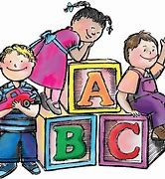
Pre-Kindergarten Pilot Set to Create Approximately 600 Regulated Early Learning Spaces in 2022-23

On May 26th, the Provincial Government announced more than 30 locations for a pilot Pre-Kindergarten early learning program that will open in 2022-23. The pilot will result in approximately 600 new regulated child care spaces in communities throughout the province.
These locations are the first in the
Pre-Kindergarten early learning program created through the Federal-Provincial Early Learning Action Plan, set for full implementation by 2025-26.
The full list of locations in the pilot can be found below.
As a regulated full-day early learning program, families will pay the regulated child care rate for each child in Pre-Kindergarten ($15 per day for the remainder of 2022, $10 per day starting in 2023). The program will run full-time, including during the summer months.
The Pre-Kindergarten program will be run by not-for-profit organization(s), and registration dates for families will be announced by these operator(s) once opening dates are finalized for each site.
The Department of Education have released a Request for Proposals (RFP) t allowing established not-for-profit groups to submit their qualifications and apply to run these facilities. All applications will be considered, with preference given to organizations that demonstrate they can run multiple locations. The deadline for submissions is June 6, 2022.

The first locations will open in either Fall 2022 or Winter 2023 to any child who starts Kindergarten in September 2023. Pre-Kindergarten spots will be available to any child in this age range, whether they have existing child care or not, as any child transferring from an existing child care location will open up a spot in their previous service for new children. Details on the registration process will be provided in the coming weeks once operators are confirmed.

At full implementation, the province-wide Pre-Kindergarten program will create approximately 3,100 regulated spaces by 2025-26, which will open up existing child care spaces for younger children.
The Provincial Government continues to maintain a contact list of anyone interested in working in the Pre-Kindergarten pilot program. If you are interested you are encouraged to email PreK@gov.nl.ca to join the contact list for the application process. Hiring preference will be given to early childhood educators holding a Child Care Services Certification (CCS) Level III or higher, including those who left the sector while holding this certification.
To ensure that Pre-Kindergarten will be a play-based program with consistent programming in all locations throughout the province, any staff hired to take part will be required to complete a short orientation course related to the early learning framework, developed in consultation with the Association of Early Childhood Educators Newfoundland and Labrador specific to work the Pre-Kindergarten setting.
Through the Early Learning Action Plan, by 2025-26 the province aims to add approximately 6,000 additional regulated child care spaces and to increase the percentage of fully certified early childhood educators working in the sector to at least 60 per cent.

Learn more
Pre-Kindergarten Request for Proposals
News Release: Governments of Canada and Newfoundland and Labrador Provide Update on Pre-Kindergarten and the Early Learning and Child Care Action Plan
News Release: Federal-Provincial Action Plan on Early Learning and Child Care Released
News Release: $10 a day child care for families in Newfoundland and Labrador

MUN Survey/Research Project for Parents
Exploring Parental Attitudes Towards Classroom Assessment.

My name is Dr. Andrew Coombs and I am a faculty member in the Faculty of Education at Memorial University of Newfoundland and Labrador. I am conducting a research project called, Exploring Parental Attitudes Towards Classroom Assessment. The purpose of the study is to hear your thoughts and opinions on the classroom assessment practices your child(ren) have experienced.

I am contacting you to invite you to participate in a survey in which you will be asked to offer your opinion on classroom assessment. This invitation is being made available to parents across the province. Participation will involve an anonymous survey that will take approximately 5 minutes to complete online using web-based software.

At the conclusion of the survey, you will be asked if you would be willing to participate in a follow-up focus group (i.e., phase 2 of the study) to discuss influences on your classroom assessment practice. You may, however, choose to complete the survey and not participate in the focus group at all.

If you are interested in participating in this study, please click here.

It is entirely up to you to decide whether to take part in this research. Your participation is not required and no information regarding your decision to participate will be recorded.

If you have any questions about me or my project, please contact me by email at andrewjc@mun.ca or by phone 709.864.7537.

Thank you in advance for considering my request,

Dr. Andrew Coombs
Postdoctoral Fellow, Faculty of Education
Memorial University

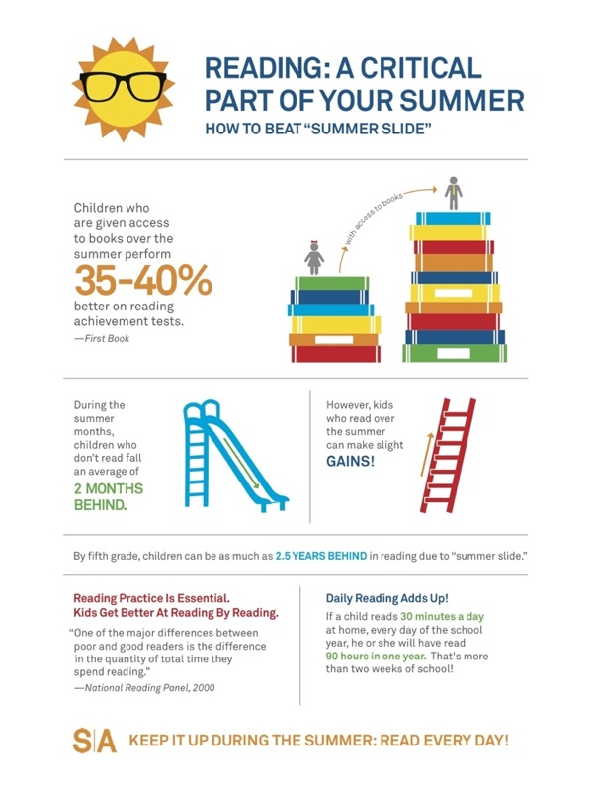

As we move into the summer, it is extremely important that students continue their growth in reading and literacy. Reading 20 minutes a day will allow students to continue that growth. Reading on grade level is one of the strongest indicators of success for students.
For many students, summer can provide time away from school to leisurely read for fun and interest. There is plenty of research to support the benefits of summer reading, especially when it comes to preventing a decline in reading skills also known as the “Summer Slide”.

Evidence suggests the summer slide is a real problem and continuing purposeful reading habits over the summer can help prevent learning loss.
Sustaining good reading habits over the
summer positions students to succeed in the coming school year.
There is a lot of research that says “regardless of ethnicity, socioeconomic level, or previous achievement, children who read four or more books over the summer fare better on reading comprehension tests in the fall than their peers who read one or no books over the summer.”

Summer can provide the opportunity for
children to take ownership of the reading process and gives agency to students to read on their own terms. The more casual nature of summer reading lets students blossom into their identity as readers.

Tips to make reading enjoyable for your children this summer:

- Read aloud together with your child every day. Make it fun by reading outdoors on the front steps, patio, at the beach or park. Also, let your children read to you. For younger children, point out the relationship between words and sounds.

- Set a good example!
Parents must be willing to model
behavior for their children. Keep lots of
reading material around the house. Turn
off the TV and have each person read his
or her book, including mom and dad.

- Read the same book your child is reading and discuss it. This is the way to develop habits of the mind and build capacity for thought and insight. Let kids choose what they want to read, and don't turn your nose up at popular

- Buy books on tape, especially for a child with a learning disability. Listen to them in the car, or turn off the TV and have the family listen to them together.

- Subscribe, in your child's name, to magazines like Sports Illustrated for Kids, Highlights for Children, or National Geographic World.

- Encourage older children to read the newspaper and current events magazines, to keep up the reading habit over the summer and develop vocabulary. Ask them what they think about what they've read, and listen to what they say.

- Ease disappointment over summer separation from a favorite school friend by encouraging them to become pen pals. Provide children with postcards or envelopes that are already addressed and stamped. If both children have access to the Internet, email is another option.

- Make trips a way to encourage reading by reading aloud traffic signs, billboards, notices. Show your children how to read a map, and once you are on the road, let them take turns being the navigator.

- Encourage children to keep a summer scrapbook. Tape in souvenirs of your family's summer activities picture postcards, ticket stubs, photos. Have your children write the captions and read them and read them aloud as you look at the book together.

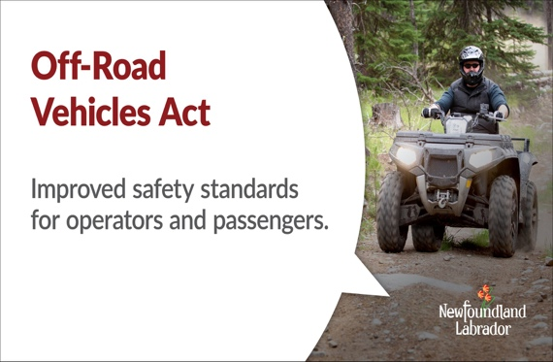

The new Off-Road Vehicles Act and Regulations, which enhance safety for all
off-road vehicle users, came into effect on May 19, 2022.
The Regulations are now available in the Gazette. For more information - https://gov.nl.ca/releases/2022/dgsnl/0510n04/

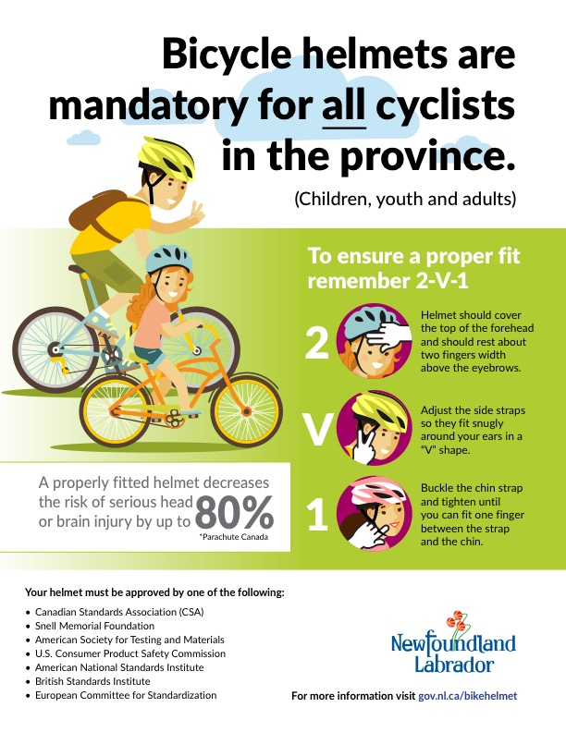

Bicycle Helmets
Anyone riding a bicycle in NL is required to wear an approved helmet. Bicycle helmets help to prevent serious head injuries when used correctly. A properly fitted helmet can decrease the risk of serious head or brain injury by up to 80 per cent
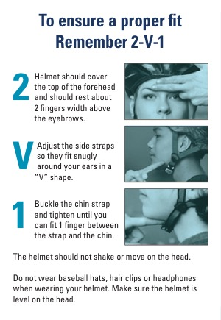
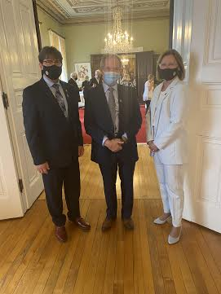

Congratulations to Don Coombs who
was recognized for his volunteer efforts in his role as NLFSC President during a reception held at government house on April 25.
The reception, hosted by Lieutenant Governor Judy Foote, took place during National Volunteer Week, April 24-30. The event highlighted the importance of volunteers and their contribution and impact on their community and province.
Don is a dedicated and loyal leader and has worked diligently to further the NLFSC mandate for excellence in education for all children in Newfoundland and Labrador.
In his role of NLFSC President Don consistently champions the cause of public education in Newfoundland and Labrador on matters affecting our K-12 school system, and works to provide meaningful input to government on
changes and decisions impacting our schools and students.
Don is well-known in the province and seen as

someone who values education. He has worked very hard to earn the respect of the many education stakeholders, particularly parents, and is often consulted by government on issues and decisions impacting the education system in NL.

Don resides in Harbour Grace and is employed
as the Chief Development Officer for the Trinity
Conception Placentia Health Foundation.
His other volunteer efforts and accomplishments include:

- Mayor of Harbour Grace for 24 years.
- Deputy Mayor for 1 year, councilor for 4 years.
- Chair of the Trinity Conception Jumpstart Foundation Chapter
- President of CBN Minor Soccer Association
- Founding Chair of the CBN Indoor Soccer Association
- Recipient of NL Soccer Association Volunteer of the Year and Queens Jubilee Medal
- Recipient of the Senate of Canada 150 Anniversary Medal
- Honorary Life Member of the Harbour Grace Volunteer Fire Brigade

Don is also a Commissioner of Oaths, a Notary Public and Marriage Commissioner
He also serves on numerous local and provincial committees. He believes in and stands for fairness, open dialogue and obtaining results in a positive professional manner.

Most of the progress and success of any organization is determined by the interest, activity and unselfish devotion of its members. Don is one of those committed members
Thank you, Don, for your outstanding and dedicated service to education and the Newfoundland and Labrador Federation of School Councils.

Sun Safety for Kids

- Use sunscreen. Apply sunscreen that has a sun protection factor (SPF) of at least 30 to protect their skin.

- Protect against UVA and UVB rays. Look for broad-spectrum sunscreens that protect against UVA and UVB rays. UVA rays can cause tanning, aging, leathery skin and skin cancer including melanoma. UVB rays can cause sunburns, skin cancer and increased moles in some individuals.
- Apply and then reapply sunscreen. Put more sunscreen on your child about every 3 hours or sooner when there is prolonged activity in the water.
- Stay inside or in the shade during peak hours. Avoid activities during peak sunshine hours (10 a.m. – 4 p.m.) when possible. Seek shade if your shadow is shorter than you are.

- Use sun protective clothing. Dress your children in a variety of available UV protective clothing that can be worn in and out of the pool/water (wide-brimmed hats, long sleeved cotton clothing and sunglasses).

By helping your child develop regular skin protection habits, you can help reduce their risk of skin cancer and ensure they safely enjoy the sun's rays all year long.

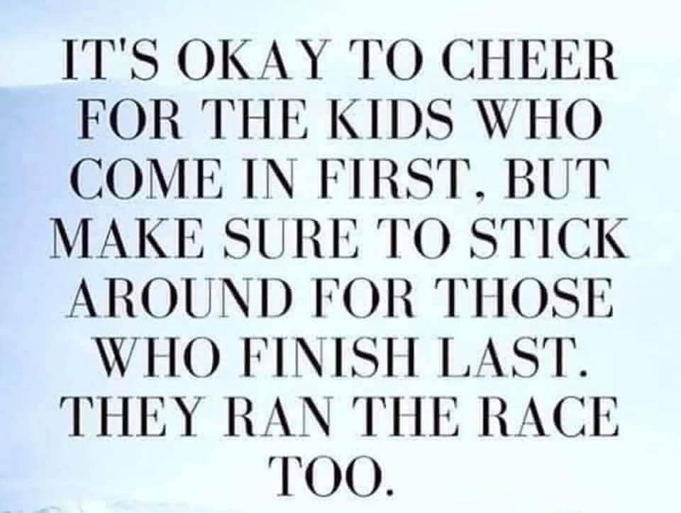

2022-2023 School Holiday Schedule

- September 6 - Administration Day
- September 7 - School Reopens/Students
- October 10 - Thanksgiving Day
- November 11 - Remembrance Day
- December 21 - Last Day - Christmas
- January 3 - School Reopens
- April 6 - Last Day - Easter
- April 17 - School Reopens
- May 22 - Victoria Day
- June 22 Last Day - Summer

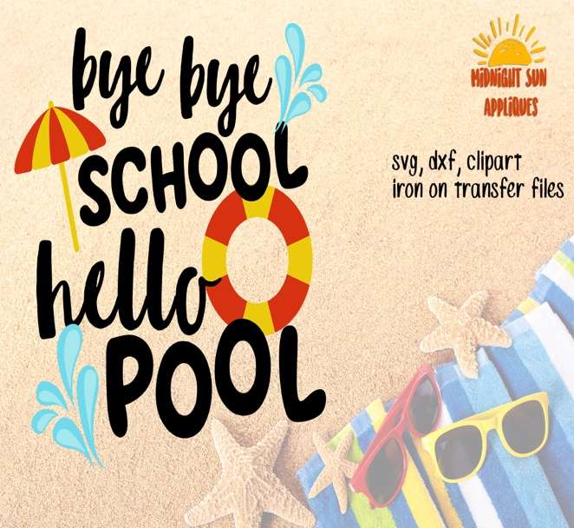

The Educator is a benefit of membership in the Newfoundland and Labrador Federation of School Councils.
Annual membership dues are based on school enrollment. Individual subscriptions are available at $15 per year.

The views expressed or implied in this
publication are not necessarily official positions of the Federation.
The mention of any program, organization,
resource, product, person, place, or school does not constitute an endorsement by NLFSC.
Editor: Denise Pike
Proof Reader: Lori Barry

NLFSC Contact Information
P.O Box 23140
St. John’s NL, A1B 4J9
Tel: (709) 764-8993
Email: nlfsci@gmail.com

